

Title: Interaction Design Assignment

Module: CMP9136M

Coordinator: Mr Wayne Christian

Student: Dean Beckerton (BEC12375372)

**Content Page**

Title Page…………………………………………………………………………………………………………………....................1

Contents Page……………………………………………………………………………………………………………………………..2

Introduction…………………………………………………………………………………………………………………………………3

Audience……………………………………………………………………………………………………………………………………..4

Idea One……………………………………………………………………………………………………………………………….(4 – 8)

- Random Image Generator……………………………………………………………………………………………..5

- Activity Chooser / Talk Groups………………………………………………………………………………………7

- Twitter (Depression Tips)……………………………………………………………………………………………….8

Idea Two…………………………………………………………………………………………………………………………........(9- 13)

- Random topic generator……………………………………………………………………………………………… 10

- Activity Chooser (Google Maps)…………………………………………………………………………………….11

- Twitter (Anxiety Tips)…………………………………………………………………………………………………….12

Idea Three………………………………………………………………………………………………………………………….. (13- 15)

* Similar Application Research……………………………………………………………………………………..13
* Storage of User Data………………………………………………………………………………………………….14
* Feature One – Avatar…………………………………………………………………………………………………14
* Feature Two – Timer………………………………………………………………………………………………….14
* Feature Three – Store…………………………………………………………………………………………………14
* Feature Four – Camera interaction……………………………………………………………………………..14

Paper Prototyping………………………………………………………………………………………………………………………….15

Testing……………………………………………………………………………………………………………………………………………16

Hi-fi Prototype……………………………………………………………………………………………………………………………….18

Development………………………………………………………………………………………………………………………………….20

Testing Iteration Two……………………………………………………………………………………………………………………...22

Refinements (Iteration Two)……………………………………………………………………………………………………………23

Future Improvements………………………………………………………………………………………………………………………24

**Introduction**

Before beginning this project, it seemed appropriate to first understand the theme behind the project. “What is Intolerance?” According to the Dictionary, intolerance can be broken down into five key points. (Dictionary, 2016)

* Lack of tolerance; unwillingness or refusal to tolerate or respect opinions or beliefs contrary to one's own.
* Unwillingness or refusal to tolerate or respect persons of a different social group, especially members of a minority group.
* Incapacity or indisposition to bear or endure: intolerance to heat.
* Abnormal sensitivity or allergy to a food, drug, etc.
* An intolerant act.

This definition allowed me to understand the concept of intolerance, from this it seemed appropriate to break down the term into a number of different themes through the use of a mind-map, such that a number of ideas could be developed with more ease.

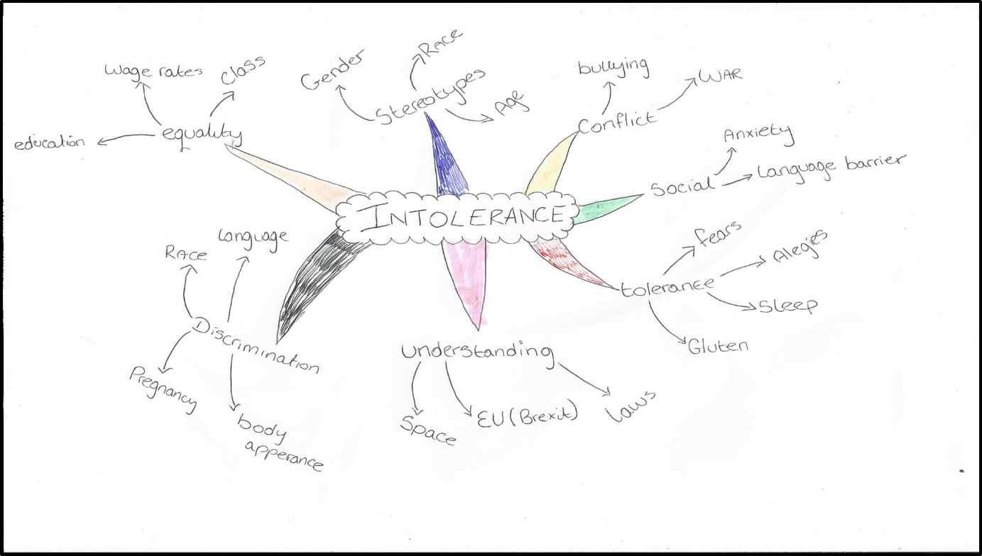

***Figure 1 – Mind Map***

After implementing the Mind map, it was necessary to make sure that the ideas chosen have the ability to hit a large audience and also be accessible. Therefore, research was completed into what type of implementation could best suit this approach.

**How to Hit Large Audiences?**

Firstly, research was completed into what devices are most popular in the United Kingdom. According to recent research into device statistics, Smart phones are now the most popular device “Smartphones overtake laptops as UK internet users’ number one device” (Ofcom, 2015) not only have Smart phones became the most popular device, they are in the hands of most young-adults “The vast majority (90%) of 16-24 year olds own one” (Ofcom, 2015) Therefore it could be appropriate to develop ideas for a mobile application with a young target audience.

Another factor that is important when thinking about mobile development and the ability to hit a large target audience is the platform that the application is planned to be developed upon. This is because mobile applications have to be specially developed for each platform.

According to recent research into the current market share of each platform, Android seems to be the clear winner “Blackberry continues to languish even further, dropping from 0.4 percent market share to 0.2 percent market share. iOS dropped from 17.9 percent to 14.8 percent, while Android saw a rise from 78.8 percent to 84.1 percent.” (Cnet, 2016) Therefore it seems appropriate to develop the artefact with an Android based platform.

**Idea One - Depression App**

According to recent research findings a large chunk of the UK population has suffered some type of depression in their lifetime “Up to 20% of people experience symptoms of depression.” (Clinical Depression, 2016) Furthering this point, research also suggests that the rate of people suffering depression is also on the increase “10 times more people suffer from major depression now than in 1945.” (Clinical Depression, 2016) Lastly according to research, depression is the leading cause of suicide “Up to 80% of suicide deaths are in sufferers of major depression.” (Clinical Depression, 2016) This research highlights a clear issue that needs to be fixed.

In order to address this issue, the idea of developing a mobile application seemed appropriate that could both assist with users facing depression but also educate users about depression, in the hope that this will reduce the rising number of people facing depression and the negative impacts that come along with it. A brief illustration of both the idea and functionality can be seen below.

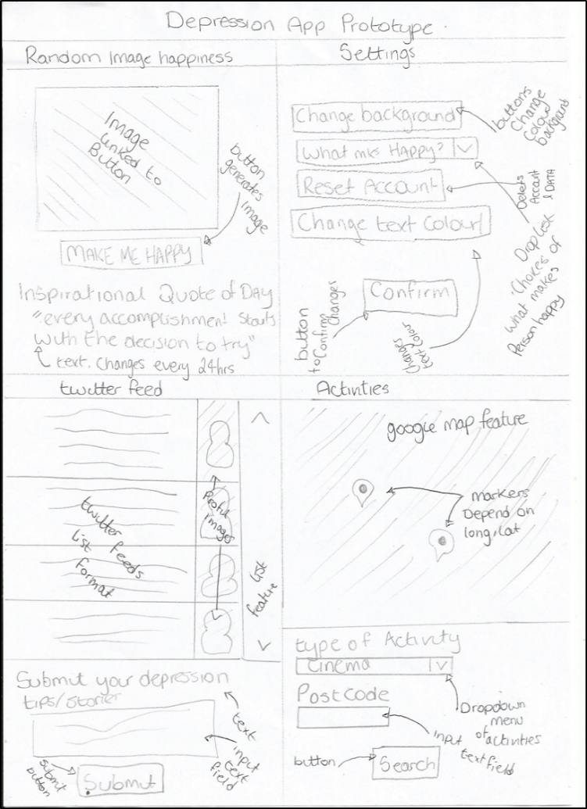

***Figure 2 – Idea Illustration***

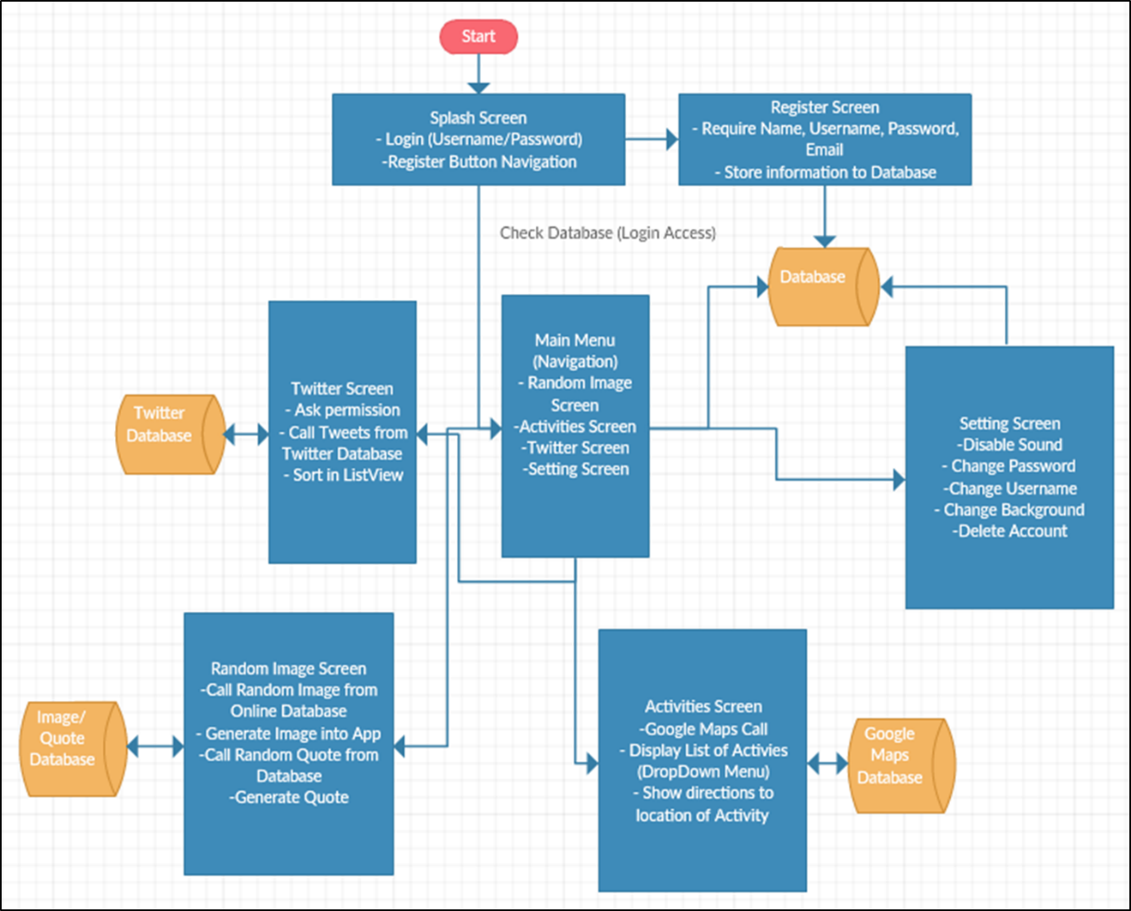

***Figure 3 – Idea One functionality***

**Idea One Features**

**Random Image Generator (Make Me Happy)**

The idea behind this feature is that the user can interact with a button or some similar type of interface that would then call an image and display it. The idea process behind this image, is that it will cheer the user up, for example, an Image of a Cute Dog Appears, this results in the user smiling and laughing. The idea behind the interface functionality of this feature is that the image depends upon what the user has recently liked on Facebook, thus this is then called to the application and then presented.

It seemed necessary to test if this interaction was possible to implement. Therefore, it was necessary to develop a simple app that had the ability to call information from the Facebook database. Android studio was used to develop this application since this was already installed upon my computer and is the official development software for Android applications. I began developing by firstly creating a Facebook developer account, this outputted the required information to call the data from the Facebook database, both the app identification and the App secret code.

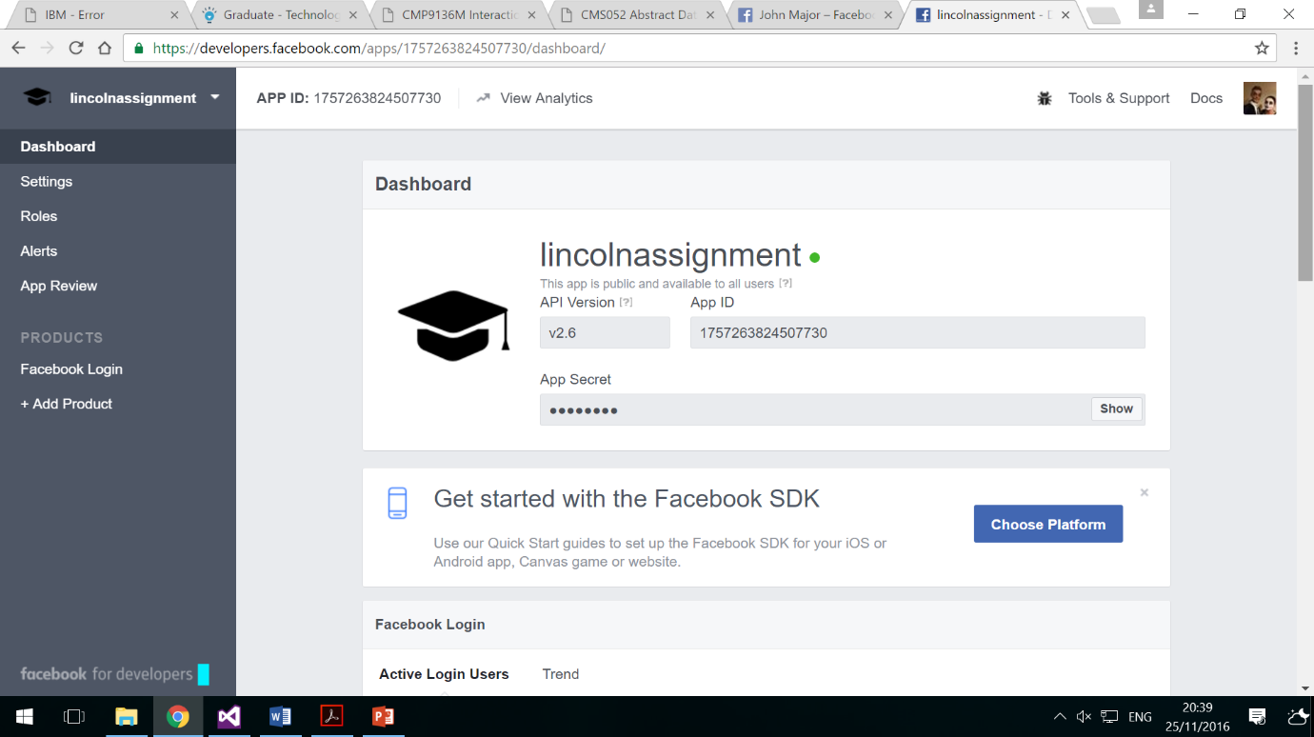

***Figure 4 – Facebook App ID and Token***

The next main process of this development required the use of the Facebook Graph API, since this is the primary method to get data both in and out of Facebook. Using this feature I was able to call many different types of information (Name, Age, Devices, Gender, Email)

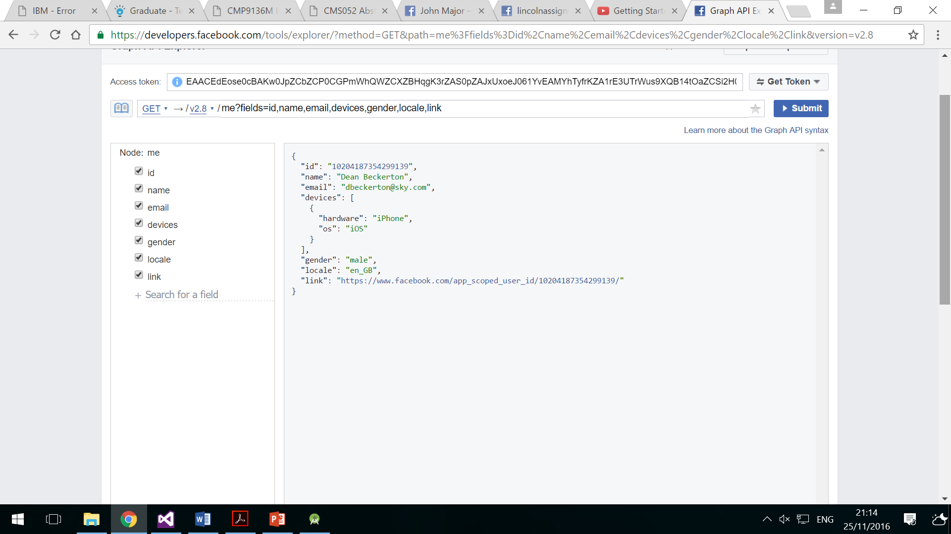

***Figure 5 – Facebook Graph API Explorer Example***

Further investigation revealed that I was able to develop a simple application that allowed the user to interact simply by logging into their Facebook account and then pulling basic information. Unfortunately, this was not the plan for this feature, therefore this idea needed to be tweaked to overcome this issue. Therefore, to overcome this issue it was decided that instead an internal database may be more appropriate with the user having the ability to pre-select categories that make them happy, and then randomly display images within those sub-categories.

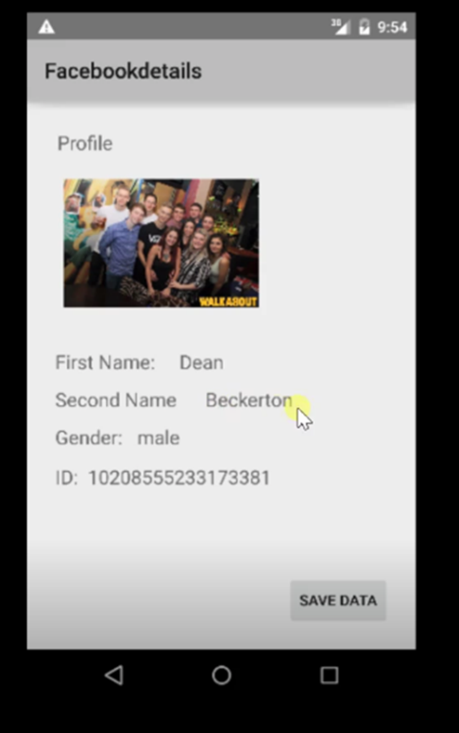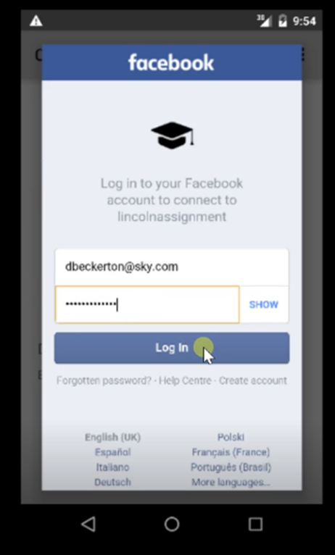

***Figure 6 – Basic App, Calling Facebook Data***

**Feature Two – Activity Chooser / Talk Groups**

This feature came apparent after doing some research for assistance with depression around the local area, it seemed to be that there were many places in Lincoln that assist the public with depression, but when I attempted to search for these places on the Google search engine “places to go to chat about depression in Lincoln” there seemed to be no interactive feature to show users where they could find these places, therefore it seemed effective to implement a Google maps feature to show users places they can go to possibly get help with their depression.

Again it seemed necessary to test if this was possible to implement. Therefore, it was decided to develop a simple app that used the Google maps API, to allow the user to interact with and show local depression centres for the user. Again Android studio was used to develop this feature, this was extremely handy as Android studio itself has a pre-built activity creator for the Google Maps API, this created the entire main feature as well as its token access, this subsequently saved a lot of time and could be handy when developing.

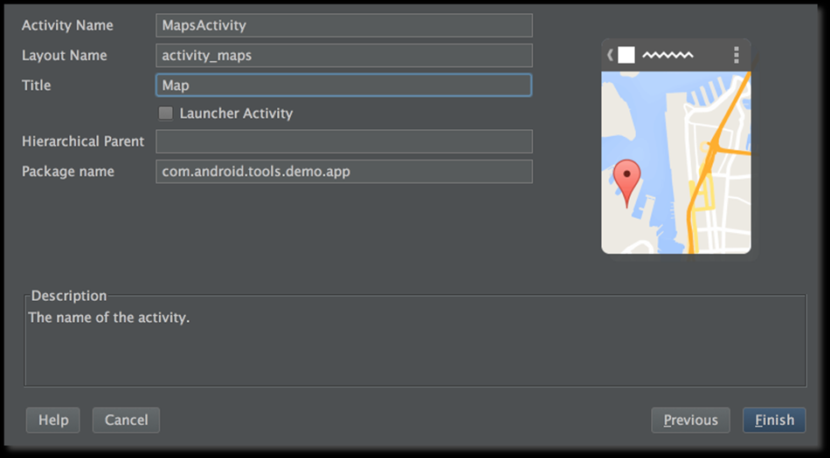

***Figure 7 – Google Maps API Setup***

Lastly all that was really required to finish the testing of this feature was the implementation of pointers. This was completed by simply finding the longitude and latitude of the areas that were required to be shown, from this Google Maps feature can then navigate the user to the pointer position. An example is shown below as Odeon as the pointer of destination.

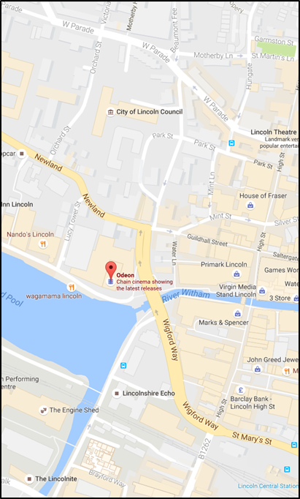

***Figure 8 – Google Maps Example***

**Feature Three – Twitter (Depression Tips)**

The idea behind this feature is that the user interacts with other users and sees real life examples of how other people deal with depression in the hope that they can both help their own depression but also be educated on the effect of depression.

In relevance to the testing of this idea, research led to a tool known as Fabric, this tool allowed for a much simpler method of creating handling options for formatting the data passed both to and from Twitter, this allowed for a lot of time saving. Once this tool had been setup the next requirement was to call only specific information from the Twitter database, this was completed by using a search query which simply specified the parameters of the search and then searched through the database for the specific information. The results of this are displayed below.

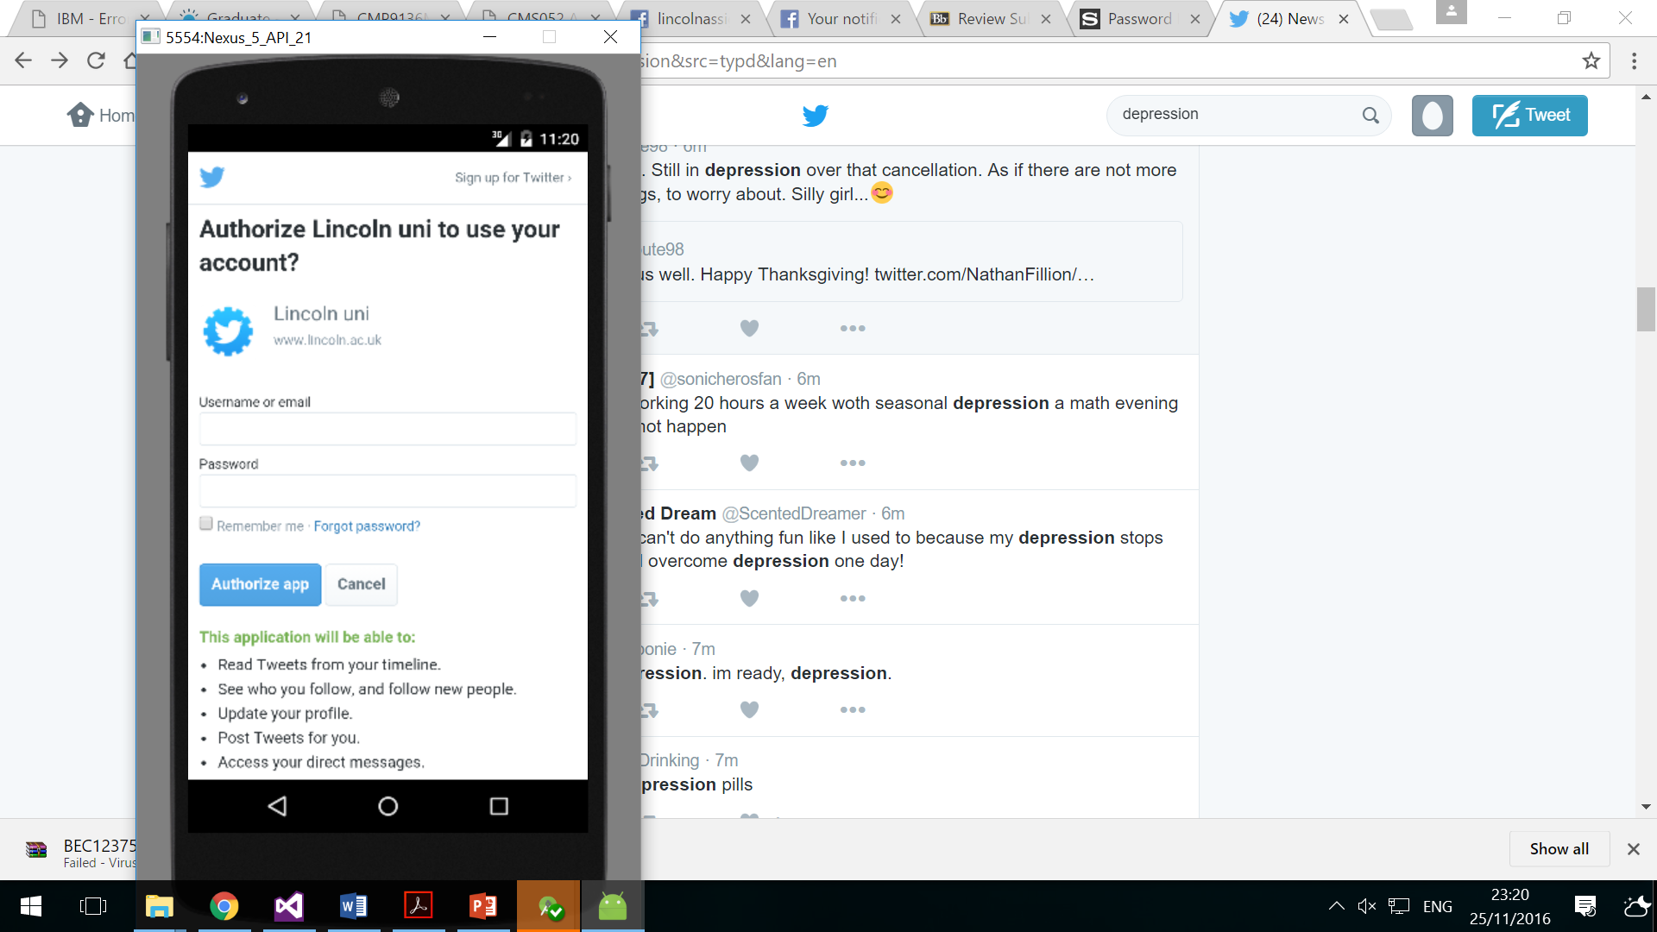 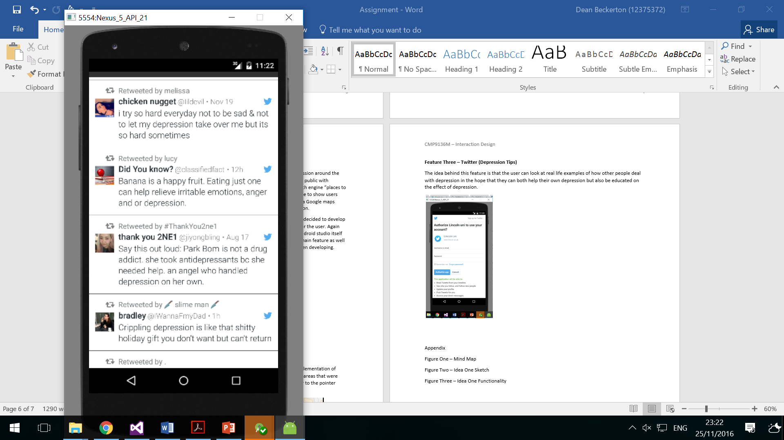

***Figure 9 – Twitter Depression Example***

**Idea Two - Social Anxiety App**

According to recent research another large issue that fits in with the intolerance theme is social anxiety. Recent research suggests around 20% of the UK population have some type of social anxiety “UK Wellbeing Survey, nearly 1 in 5 people in the UK aged 16 and older showed symptoms of anxiety.” (Mental Health, 2015) additionally on top of this figure GP’s also report that most of their consultations had some link to social anxiety “a total of 202 GPs in the UK reported that 84% of their consultations were attributed to issues with stress and anxiety.” (Mental Health, 2015) Again this is another issue that clearly is a significant problem within our society and needs to fixed.

In order to address this issue, again the idea of developing a mobile application seemed appropriate that could both assist with users with social anxiety but also educate users about different types of anxiety, in the hope that this will help reduce the number of the people in the UK with social anxiety. A brief illustration of both the idea and functionality can be seen below.

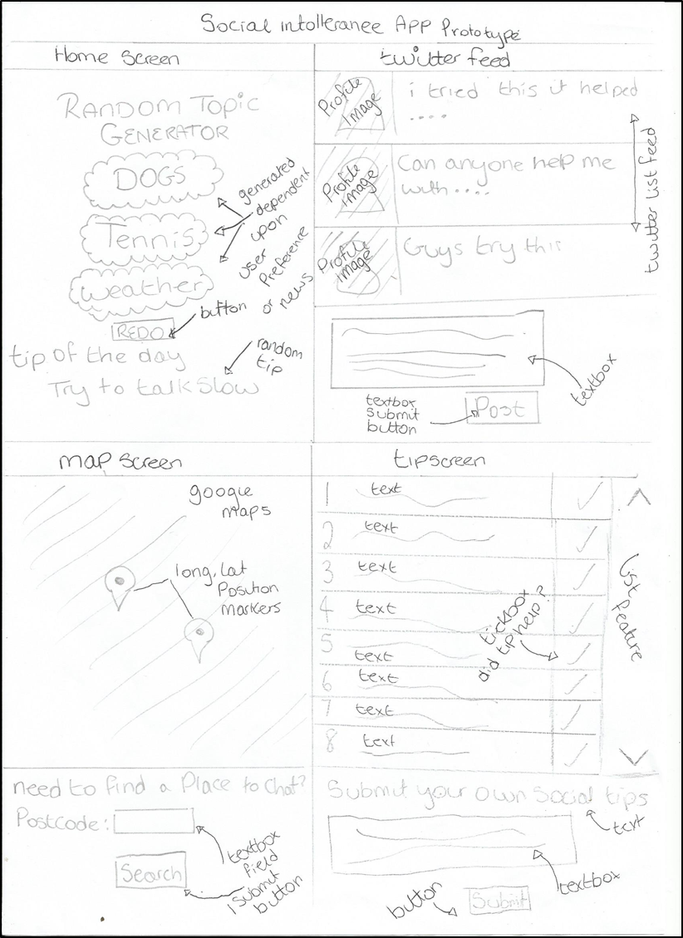

***Figure 10 – Sketch Idea Two***

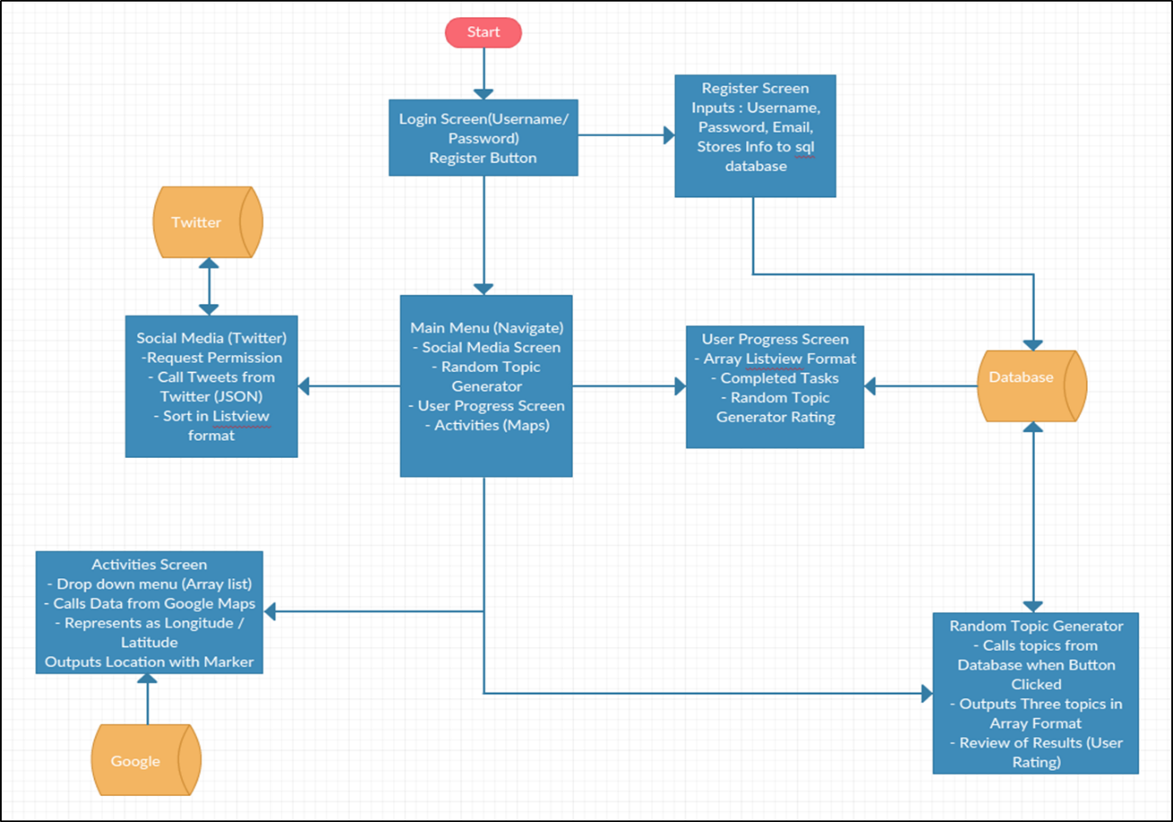

***Figure 11 – Functionality Idea Two***

**Idea Two Features**

**Feature One - Random topic generator**

The idea behind this feature originated from a house mate, who sufferers from social anxiety, they commented that one of the largest problems with their anxiety is the ability to come up with something to speak about. Therefore, the idea behind this feature is that on the interaction with a button or some other similar feature, a number of topics appear for the user to speak about, these topics will be called from an in-built application database. In relevance to the topic generation, research was completed into what topics would be best appropriate “A well-worded question is the quickest way to connect after a long day. We call them starters because we imagine they will spark a deeper conversation about the things that matter to you. “(Family Dinner Project, 2016) This research allowed for the ability to find an appropriate source for conversation starters. Conversation starters world, was a very appropriate source for these questions, purely due to the number of conversation starters within their database being over 250, meaning the random conversation generator will likely not repeat the same conversation starters in a short period of time.

The idea behind the functionality of this feature will be that each conversation will be stored as an array and use a randomisation formula to choose between values within the array “int x = rand.nextInt(max - min + 1) + min;” (StackoverFlow, 2011) Thus outputting a random conversation starter “When was the last time you went to a movie theatre?” (Family Dinner Project, 2016)

**Feature Two – Activity Chooser (Google Maps)**

The thought process behind this feature was derived from idea one. Research was completed into social anxiety and how to overcome the issue. One recommendation research suggested was to be more socially active and to attend more social events “Social situations that provide opportunities for repeated contact are the best ways to develop friendships. Try and brainstorm ways to get involved with other people.” (Anxiety BC, 2016) Thus the idea came apparent to develop a feature that links many social events to a Google maps feature. The interaction of this feature will work similar to that of idea one. The main differences between the functionality of idea one, is that this feature will have some type of menu system (Drop-down) to select a type of social event, this will then display the events location and time via a Google maps display.

In relevance to the activities chosen, this will be called from the Yelp API. This program allows for the ability to call local activities around your area dependent upon your longitude and latitude, therefore meaning the activities displayed will always be both up to date and accurate. An example of one of these location calls is shown below.

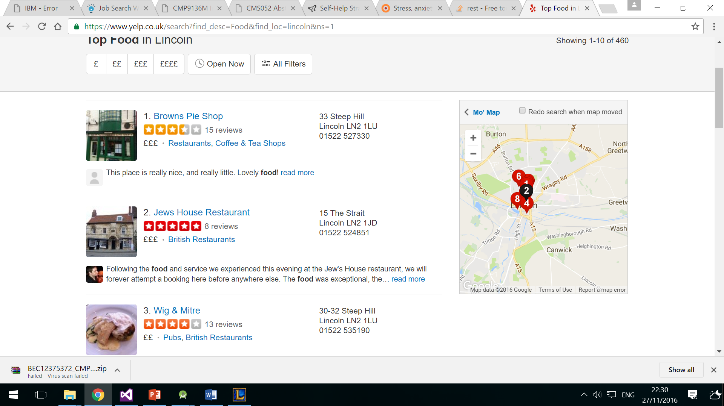

***Figure 12 – Yelp API***

**Feature Three – Twitter (Anxiety Tips)**

The idea behind this feature again came from mainly research. NHS research recommend reading about other people’s anxiety issues “If you're feeling sad, anxious, angry or stressed, remember you're not alone. Read real-life stories from other people who have felt the same way.” (NHS, 2015) Thus this lead to a similar idea to that of idea one. The idea behind the functionality of this idea is that the user interacts by inputting their twitter credentials (password, username) and then can read stories in some type of list view using the Twitter API, but also can input their own stories, thus allowing them to make more social connections and get help from other people who may suffer similarly.

**Idea Three - Kids Teeth Assistance Tool**

According to recent research another large issue that fits in with the intolerance theme is social anxiety. Recent research suggests around 20% of the UK population have some type of social anxiety “UK Wellbeing Survey, nearly 1 in 5 people in the UK aged 16 and older showed symptoms of anxiety.” (Mental Health, 2015) additionally on top of this figure GP’s also report that most of their consultations had some link to social anxiety “a total of 202 GPs in the UK reported that 84% of their consultations were attributed to issues with stress and anxiety.” (Mental Health, 2015) Again this is another issue that clearly is a significant problem within our society and needs to fixed.

In order to address this issue, again the idea of developing a mobile application seemed appropriate that could both assist with users with social anxiety but also educate users about different types of anxiety, in the hope that this will help reduce the number of the people in the UK with social anxiety. A brief illustration of both the idea and functionality can be seen below.

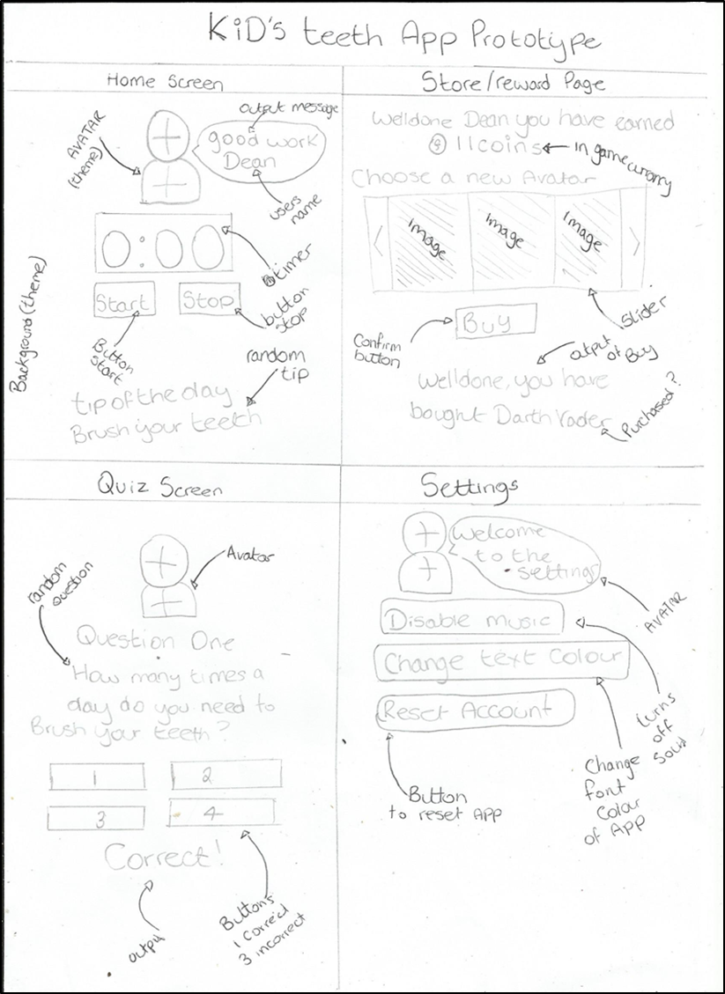

***Figure 13 – Idea Three***

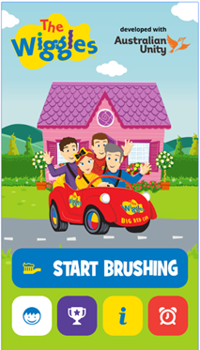**Similar Application Research**

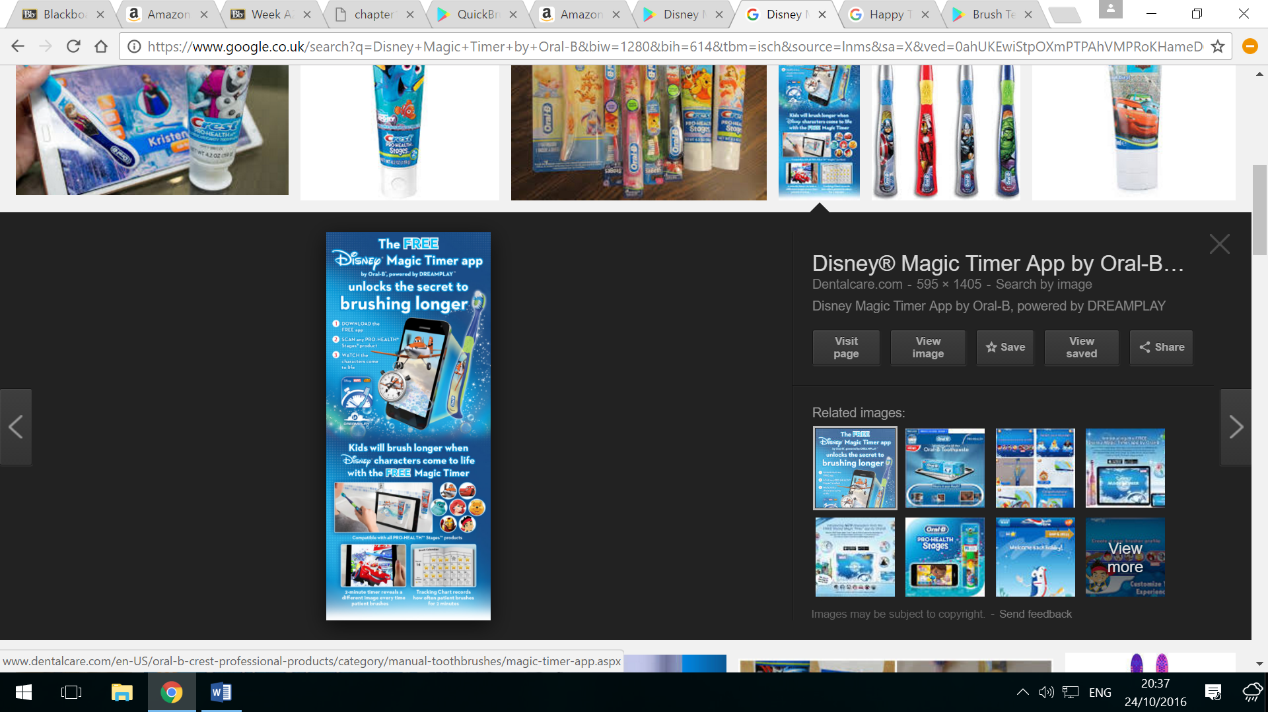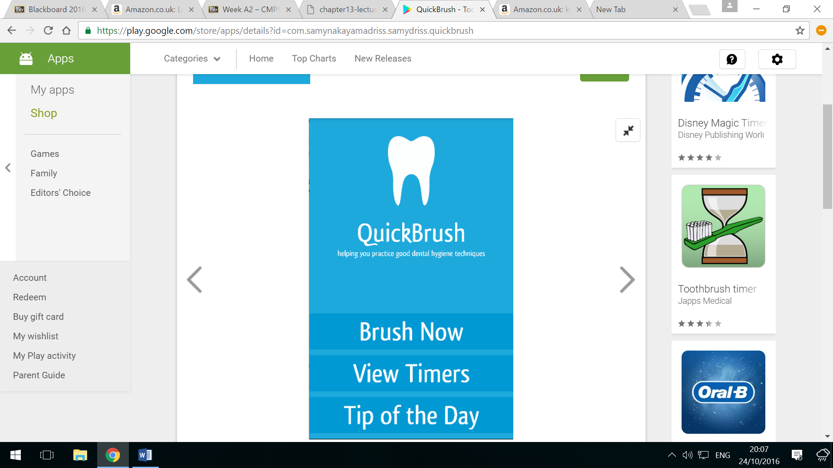

***Figure 14 – Similar Research***

**Quick Brush** – This application includes a number of useful interactive features, including timers to brush your teeth at the correct time, illustrations to demonstrate how to effectively brush your teeth and a number of daily tips to increase user interest. Secondly the application is simple making it easy to use and understand. Alternatively, there are a number of things that make this application less effective, Firstly the application is quite basic, making it quite boring to interact with which arguably goes against the applications purpose (Quick Brush, 2015)

**The Wiggles** – This application again has a number of useful interactive features. Firstly, it has a vibrant design which makes the application look fun and exciting which also fits its target audience (children). Secondly the application has a simple but effective navigation menu that makes it easy and fun to navigate to all screens within the application. Alternatively, there are a few disadvantages within this application, after testing the application myself and also reading a number of reviews, the application seems to crash a fair amount of time and have a number bugs, making the users interactive experience rather negative. (Australian Unity, 2015)

**Disney Magic Timer** – This application also has a number of key interactive features. Firstly, the application has a number of customisation options and a nice professional design, making the game much more addictive than other applications. Secondly, the application also has a number of advanced interactive features such as camera feature, calendar system and the ability to track user progress. In relation to the negatives of this application. One of the main interactive disadvantages of this application is its usability, it is hard to navigate around this application, alongside this issue the application also crashes frequently, making its usability quite poor. (Disney, 2015)

**Storage of User Data**

I realised I would need to figure out how I planned to store the user’s data safely, I came to the conclusion that a login/register feature would be most appropriate, since this application doesn’t communicate to other users, SQLite seemed appropriate meaning the phone itself will store the user information, this information can be stored from the user inputting their information to input text boxes and then storing the data to the database.

**Feature One – Avatar**

The idea behind this feature was derived from the similar application research completed. The idea behind the interaction of this feature is that children using this application can have a customisation choice on which avatar they wish to choose, this avatar will then assist the child when brushing their teeth, assistance will come in the form of both visual rewards and communication to the child.

Furthermore, it was next appropriate to research what Avatars would be best suitable for this idea, therefore I completed research into the most popular kid’s TV characters. According to a public children's voting website, the current favourite kid’s TV characters are as follows. Sponge Bob Square Pants, Regular Show, Gravity Falls, The Fairly Odd Parents, Adventure Time, The Amazing World of Gum Ball, Phineas and Ferb, Teen Titans Go, Pokémon and Scooby Doo (TopTens, 2015)Therefore the avatars chosen for this artefact will be loosely based around the above list.

**Feature Two – Timer**

The thought process behind this feature again came from the research of similar applications. The idea behind the interaction process of this feature is that the user controls two buttons, one to start the timer and another to stop the timer, on interacting with these buttons it will activate or deactivate a chronometer to which the child must brush their teeth to until the chronometer hits zero. Alongside the interaction of this feature, this feature will also cooperate with the avatar which will also have its own unique set of interactions. Since this was a particularly easy feature to implement I felt no need testing the ability to implement this feature, therefore this will be developed if the idea is chosen.

**Feature Three – Store**

The idea for this feature was derived from the avatar feature. The thought process behind this feature is that the user uses tokens gained from successfully brushing their teeth to purchase new avatars as a reward. The interaction process behind this feature will involve some type of interactive button to navigate through numbers of different avatars, and then another button to interact with to purchase the selected avatar. Again Since this was a particularly easy feature to implement I felt no need testing the ability to implement this feature, therefore this will be developed if the idea is chosen.

**Feature Four – Camera interaction**

The idea for this feature was again derived from research. The current thought process behind this idea is that after the child has completed the interaction of brushing their teeth they can record this progress to see both their improvement and any changes to their teeth. Therefore, the interaction of this feature will involve the user taking a picture of their teeth just after they finish brushing them.

Next it seems appropriate to test if this feature can be developed in the time frame. Therefore, a basic camera application that saves an image was developed. In relevance to the functionality behind this feature, the first step requires a user interaction, this was chosen to be a button activation which then launches the Camera feature, this in turn is processed as an intent, which requests access to the camera, if this access if then granted the camera application will be launched. Lastly the user can then interact with the camera feature and take a photo, this photo is then called back to the application via an intent.

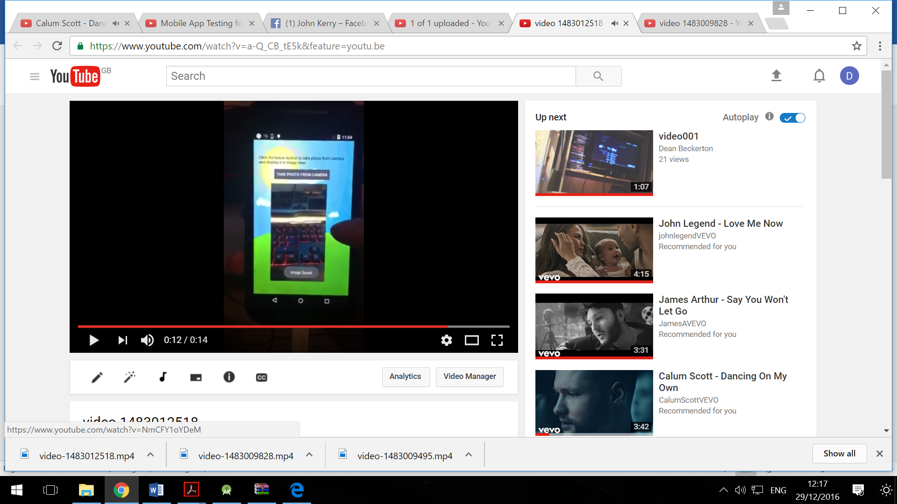 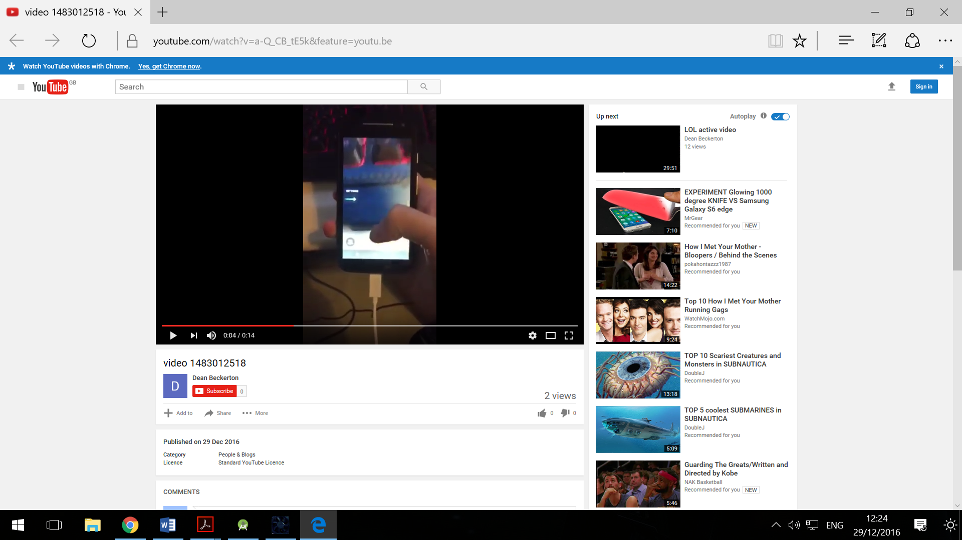

***Figure 15 – Camera Research***

See Demonstration here: <https://youtu.be/a-Q_CB_tE5k>

**Prototyping**

**Paper Prototype**

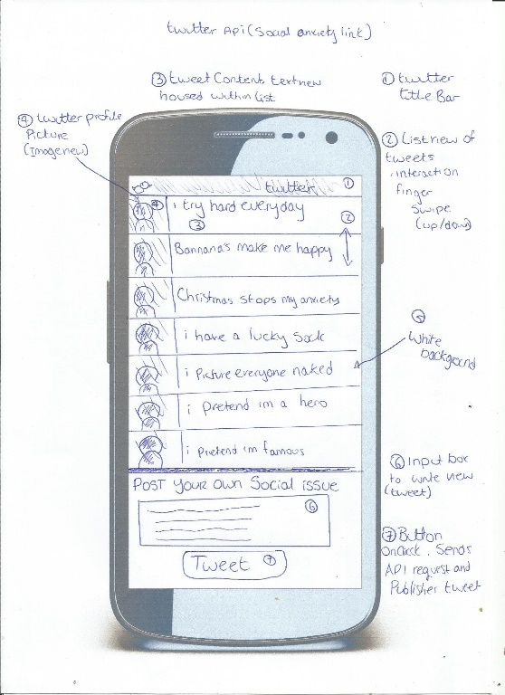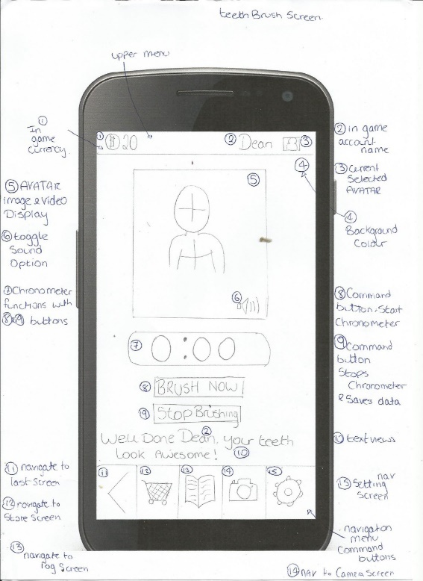The next important process was to implement a paper prototype. This firstly involved printing out a phone template to better capture and present the prototype, from this detailed illustrations and information were then implemented. The idea behind developing this prototype is to allow for testing to be completed on the interaction and other aspects of the application. An example of the Paper prototypes is shown below, for the full paper prototype visit Appendix A.

***Figure 16 – First prototype (idea three and two)***

**Testing**

Testing is vital when it comes to developing an application, even more so when interaction is a key element “Testing makes software useable; without testing there would not be an end product. Testing ensures software is consistently of high quality and effective as a product so as to meet a client’s needs.” (FDM, 2013) After understanding the importance of testing the next important requirement is to understand the type of testing required to gain an effective result, furthermore since interaction is a key element of this assignment, it is appropriate to choose a method that directly looks at user interaction “The most effective way of understanding what works and what doesn’t in an interface is to watch people use it. This is the essence of usability testing.” (NN Group, 2014)

Thus firstly the usability testing approach will be used to test within this assignment. Therefore, this testing will involve the user completing a number of set tasks, from these tasks data will be gathered in the form of ab average time to complete the set tasks, total number of errors that occurred and any additional comments. Lastly a SUS (system usability scale) will also be completed (See Appendix B), thus making sure testing is completed thoroughly to provide the best possible interaction result. This type of testing involves a Likert style approach and allows for further more accurate testing “this test is technology agnostic and can be tested with as few as two people. The SUS measures usability and learnability and should be administered after a product usability test.” (TheNextWeb, 2014) Furthermore it was decided that only ideas two and three would be tested as idea one lacked detail and the other ideas seemed more effective.

**Testing Idea Two**

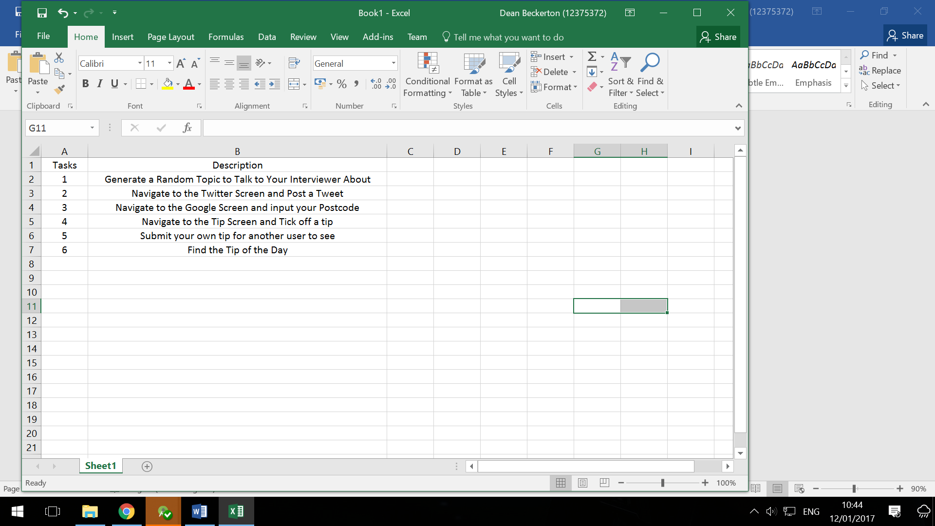

In terms of the audience for testing idea two, all audiences seem applicable since social anxiety is an illness that could occur to anyone, thus testing participants will not need to have a scope. Furthermore, participants must complete all of the above tasks and results will be recorded and analysed.

**Results**

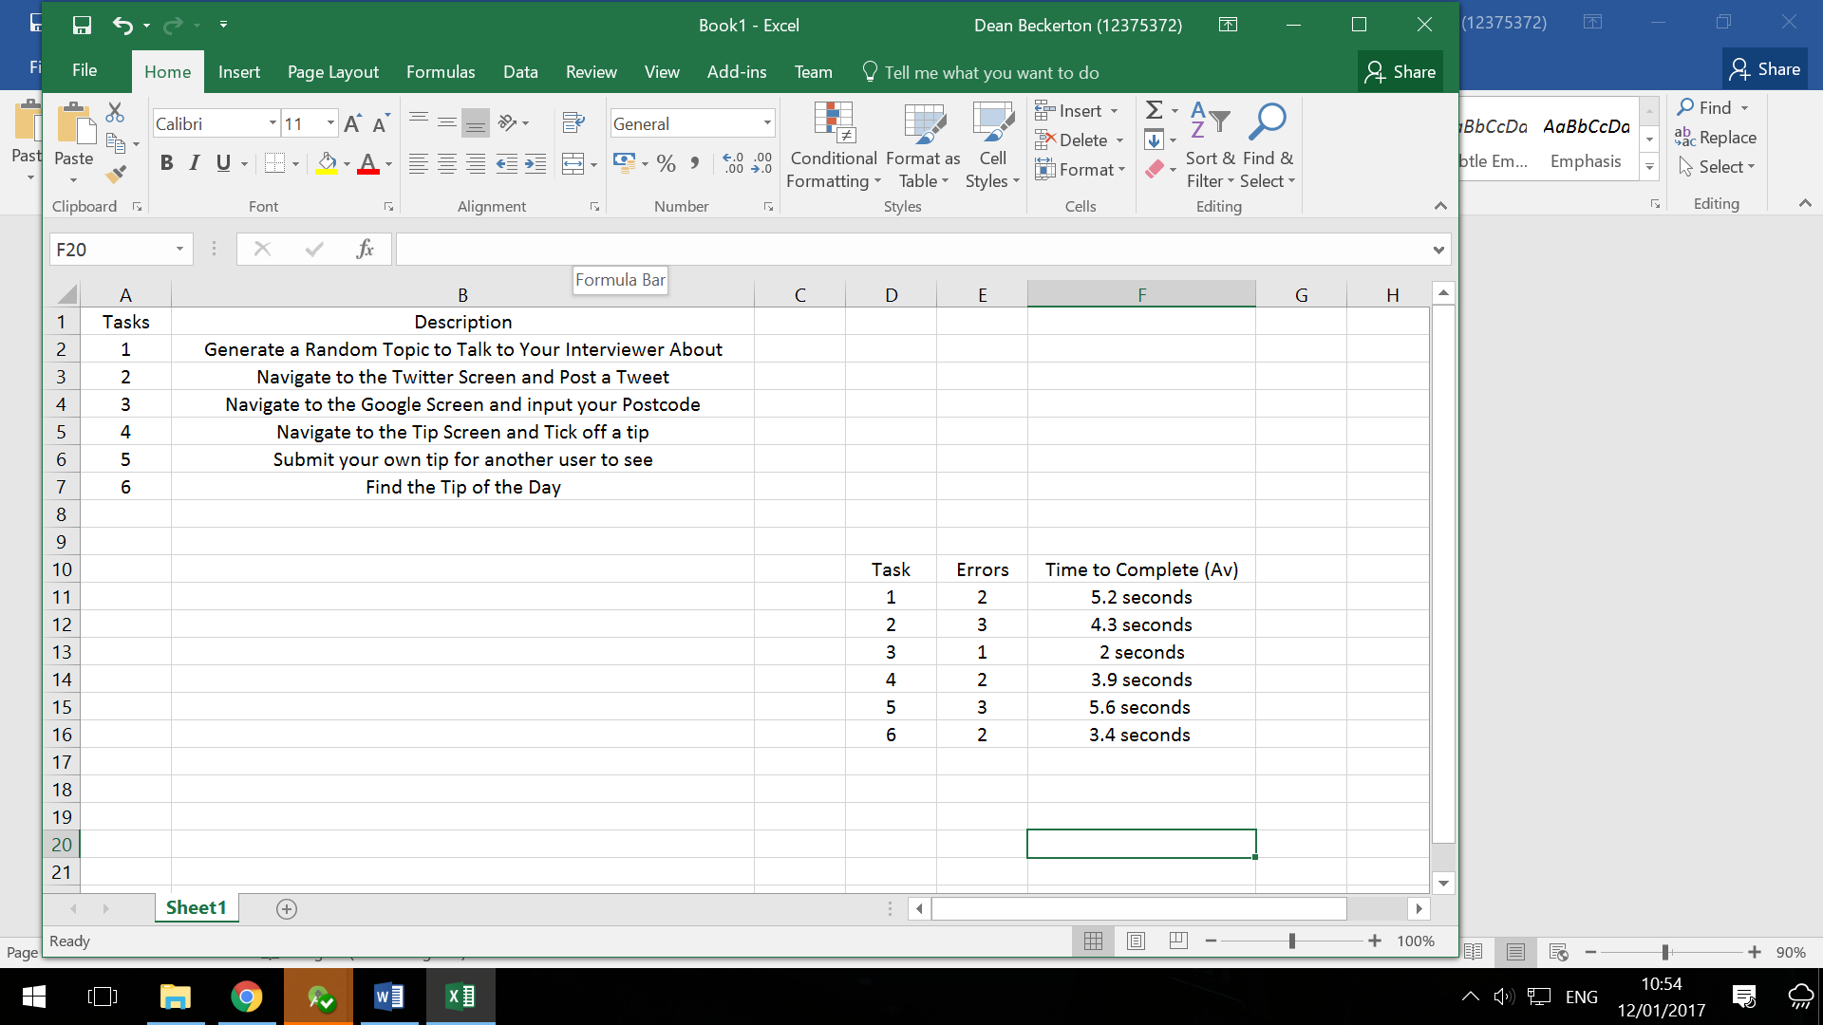

As can be seen with the results, there were a large number of errors through a number of different tasks, with times to complete also being considered, there may want to be a high level of adjustment between the first iteration prototype to the next iteration.

**Testing Idea Three**

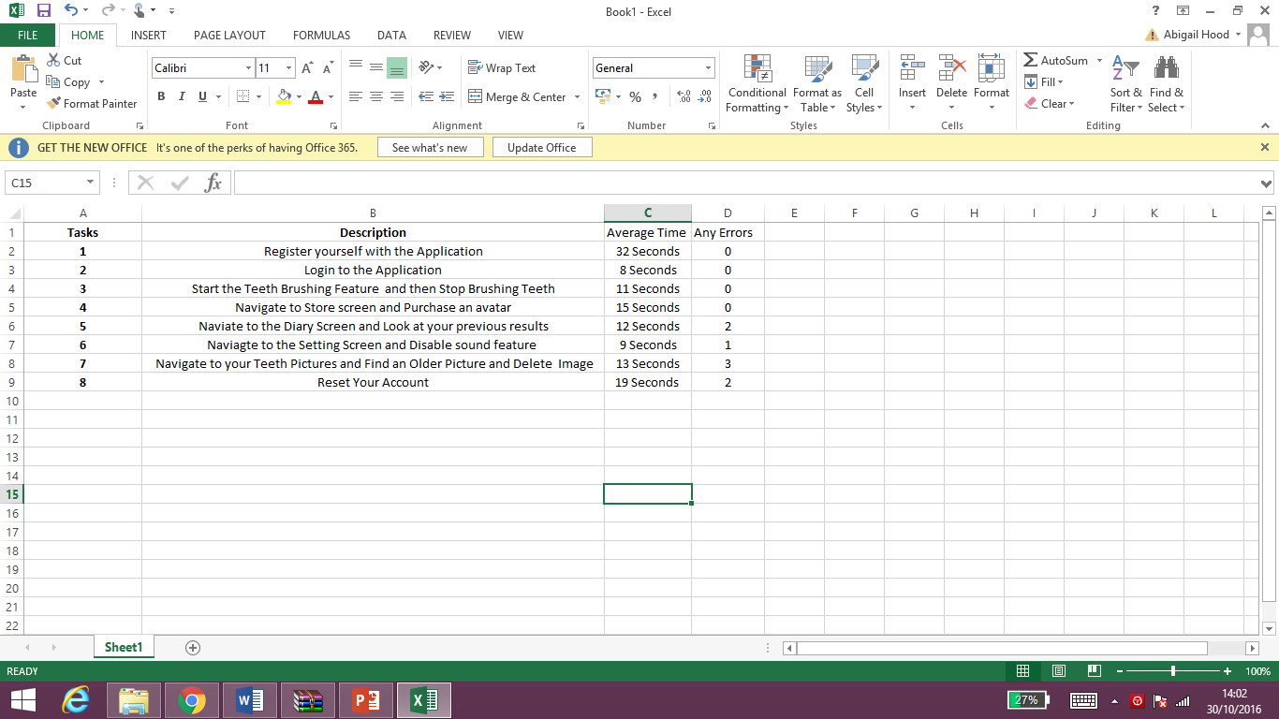

***Figure 17 – Testing Tasks***

The most important aspect of testing is the audience. Since this application is targeted at children, it would be ideal to test this audience, although in real terms this it may be more appropriate to test parents, since in reality this will be a parent’s phone and the parents will likely pilot this application for the children, thus the audience who will be testing this application will be parents.

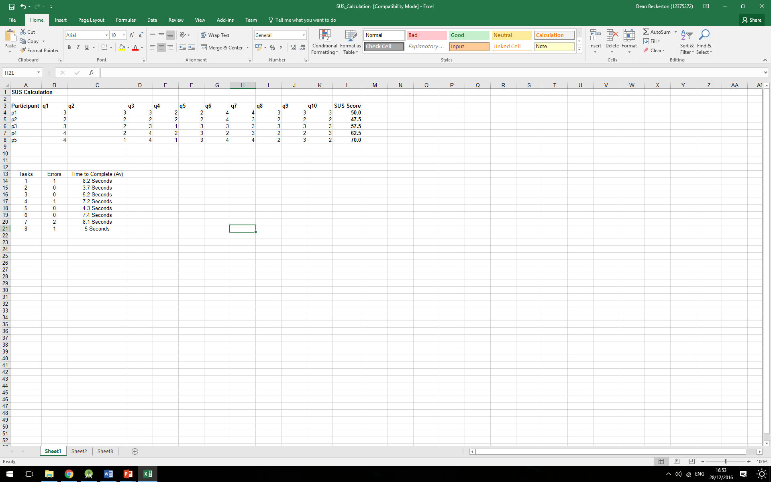**Testing Results (Idea Three)**

***Figure 18 – Testing Usability Iteration One***

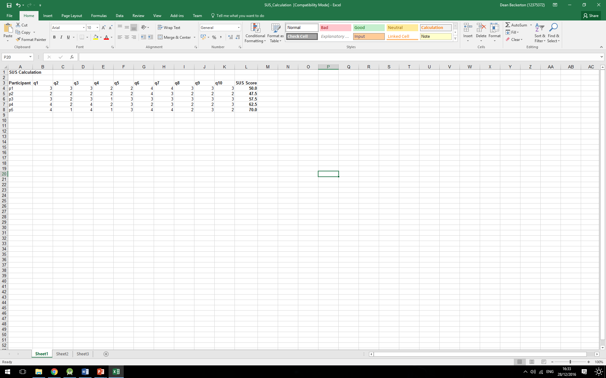Within the first iteration of testing it involved testing five participants. In relation to the first testing method, usability testing the participants managed to complete most tasks without any errors although some errors were present, after all tasks were completed participants reported that the errors were mainly due to some button interactions not being very obvious, therefore when developing the next iteration, it may be appropriate to produce a design with clear and precise interactions. Lastly the average time to complete each task seemed quite consistent across all participants, with minor participants taking slightly longer, overall there seemed no clear issue present with the time to complete each task.

***Figure 19 – Testing SUS Iteration One***

Next the SUS testing approach was completed. In relevance to the Scores achieved within this testing approach, scores ranged from 47.5 to 70.0. The results achieved from this testing did not fully meet the criteria required “a SUS score above a 68 would be considered above average and anything below 68 is below average” (Usability Gov, 2015) Therefore, as a reflection of this testing it can be argued that the interaction of this software is currently not of a high enough quality in relevance to usability standards since the average score achieved is below the recommended average guideline.

**Comments (iteration One)**

**Positive Comments**

**Avatar idea and customisation options**

**Store to Purchase Avatars with in game currency**

 **Bottom navigation menu easy to use and understand**

**Reward system good idea**

**Camera Feature interaction is fun**

**Negative Comments**

**Timer is to simple and boring**

**Diary Feature is to complex**

**Icons on menu system need more clarification also to many**

**No need for setting screen**

**There is no main menu**



**Push Nofications?**

**Reflection**

As a reflection of the additional comments made during testing, it is clear to see that there are both a large number of positive and negative comments regarding the user interaction with the application. In regards to the negative comments it is now important, to look at these issues individually to develop a high-fi prototype that when retested will have a higher quality of user interaction.

**High-fi Prototype**

Since a rough direction of the application development route has now been defined it now is appropriate to begin developing the High-fi prototype. This prototype will be developed within Android studio to provide for the best user interaction results possible since this will be the software required to develop the application.

**Timer Refinement –** Since participants commented about the timer being rather boring, it was decided to develop a more visually pleasing design. The idea for this is now a circular timer that fills as the time left decreases. Alongside this design the basic timer will also be present for a further clarification. Thus this will ideally better interest the user when interacting with the application. In relevance to the functionality of this feature, further research was required. After looking through a number of resources an appropriate article appeared, this article explained both the design implementations and animation implementations required to develop a circular timer.

**Resource:** [**http://stackoverflow.com/questions/21333866/how-to-create-a-circular-progressbar-in-android-which-rotates-on-it**](http://stackoverflow.com/questions/21333866/how-to-create-a-circular-progressbar-in-android-which-rotates-on-it) (Stackoverflow, 2014)

Thus this research identified that the clock simply required an animator function that counts in a linear fashion under a set duration, furthermore, while this animation functions it will increment two shapes, one over another, thus leading to a shape counting over another.

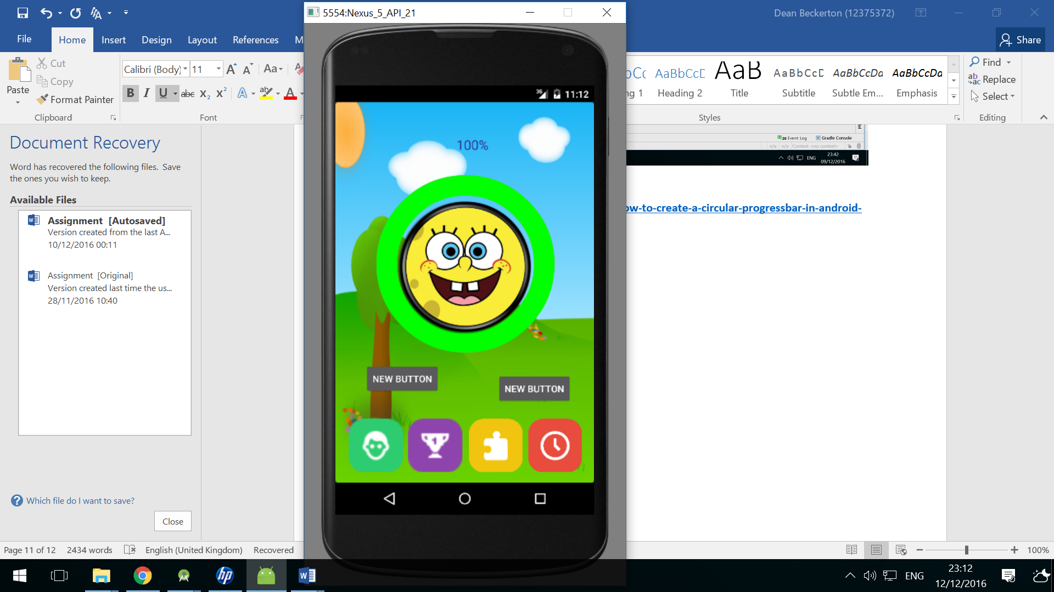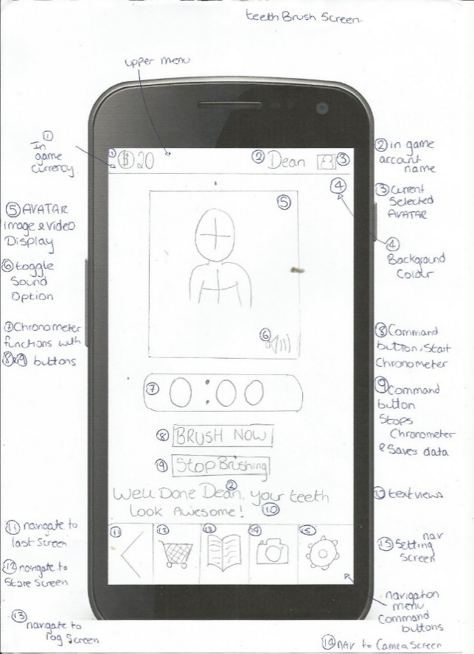

***Figure 20 – Refinement Timer Feature***

**Diary Feature to Complex –** Participants argued this feature was to complex, therefore refinement of this feature was decided to no longer include detailed information about each time the user brushed their teeth, but instead have a library of images of the pictures of their teeth. This feature will function by firstly the interaction with a button, this will then launch a slide show to which the user can interact with by sliding their finger either left or right depending upon what image they wish to display.

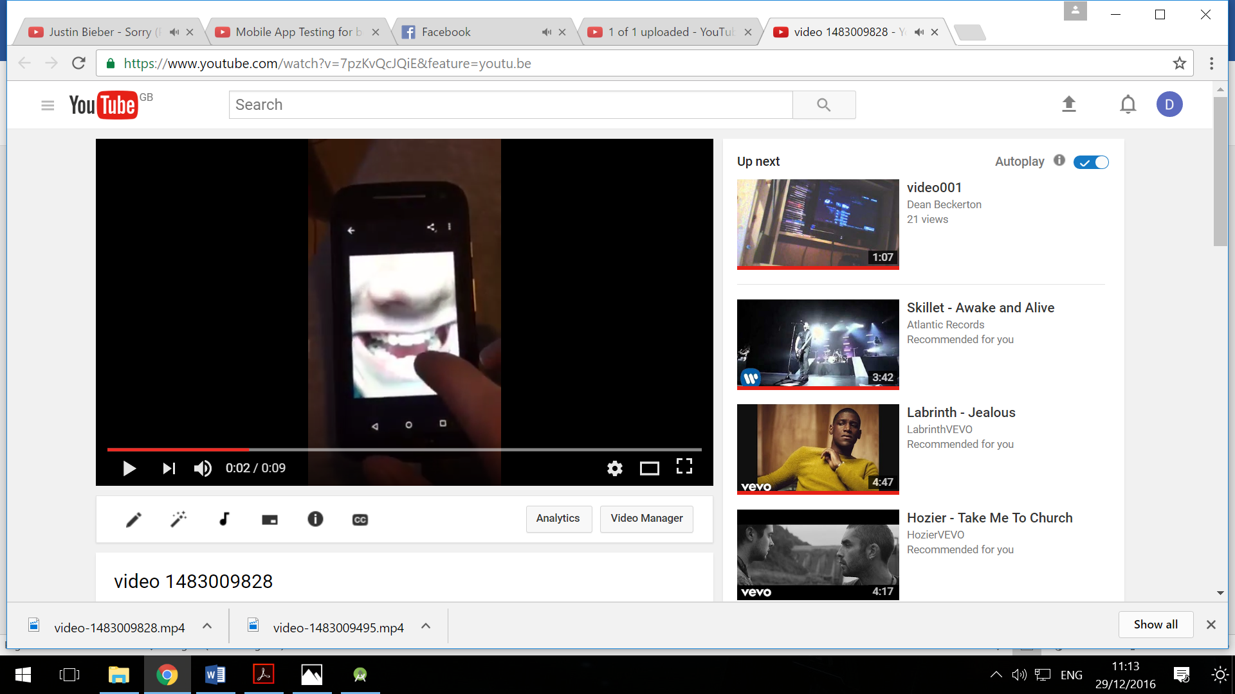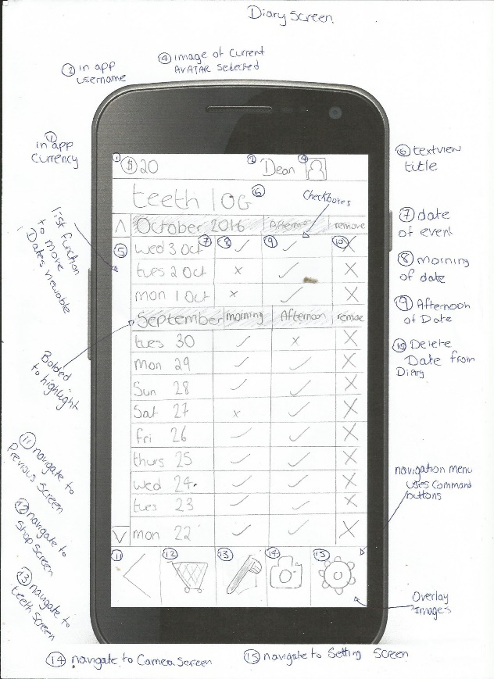

***Figure 21 – Refinement Diary Navigation***

**To see Demonstration please visit:** [**https://youtu.be/7pzKvQcJQiE**](https://youtu.be/7pzKvQcJQiE)

**Icons more clarification and to many –** Participants commented that five buttons on the navigation menu seemed to many and confused the user and also would be hard to interact with. Therefore, after completing some additional research it was decided four buttons seemed more appropriate “Avoid using more than five destinations in bottom navigation as tap targets will be situated too close to one another.” (Material io, 2016) Furthermore it was also decided to refine this menu system further by adding colour identities to each button.

To implement everything, the participants requested in the menu navigation it seemed necessary to find an online tool to asset with a professional development, therefore icons8 was suggested by a friend, after closer inspection this software seemed ideal due to the vast number of customisation options available and icons that could be developed into picture buttons (icons8, 2016)

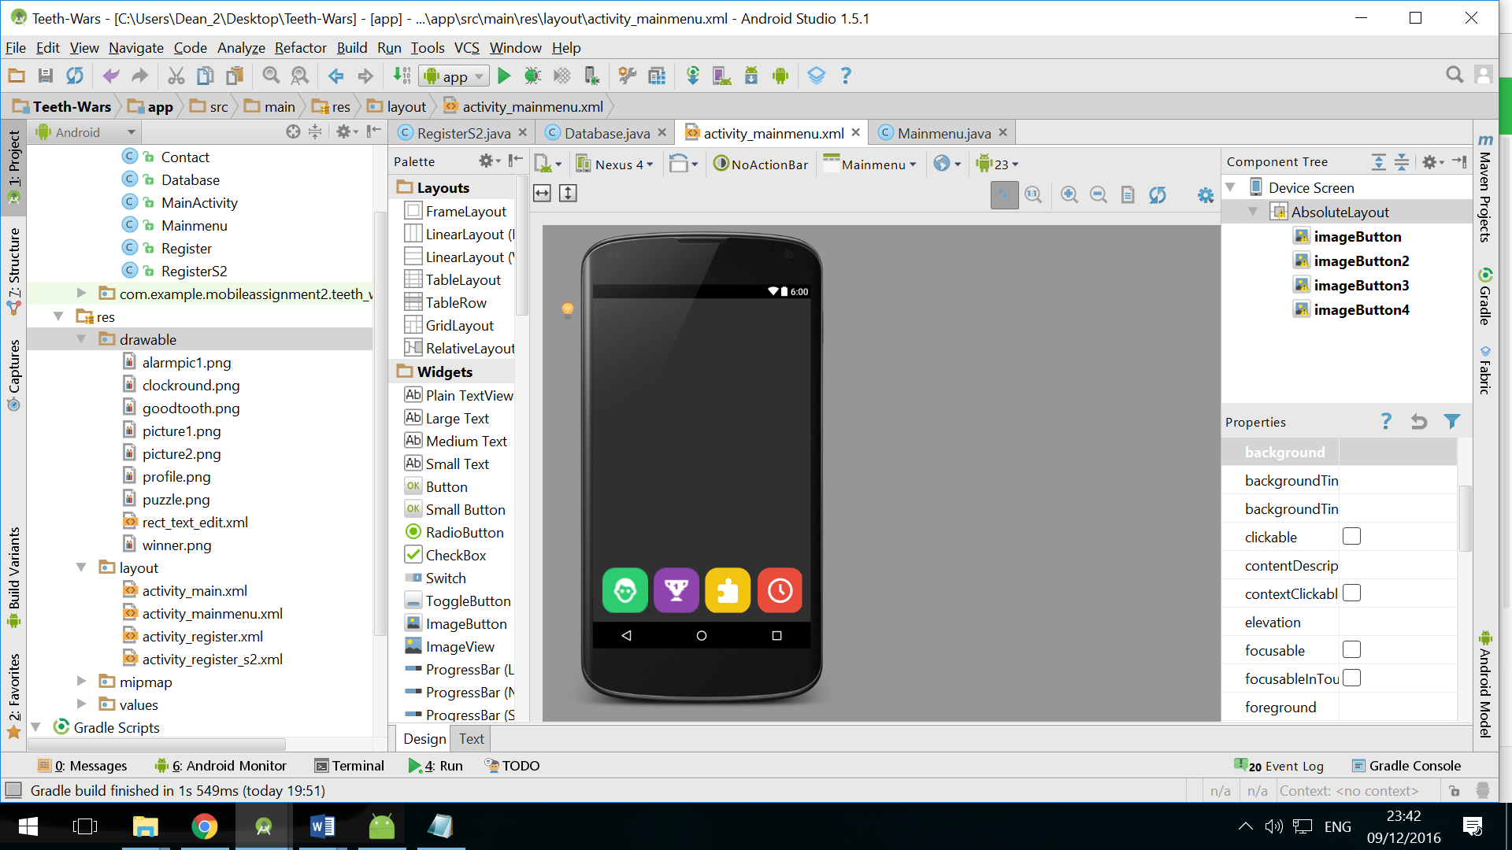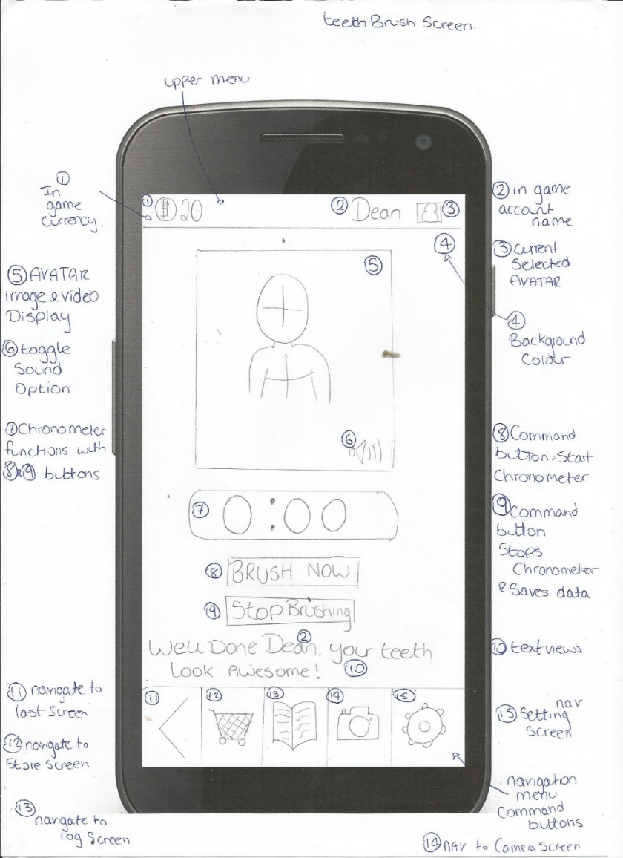

***Figure 22 – Refinement Bottom Navigation***

**No Need for Settings Screen** – Since many users commented on the unneeded the activity screen, it was simply decided to remove this feature and adapt small features such as changing the avatar into the Diary screen.

**No Main menu** – Since there was no main navigation hub for this application and users seemed to dislike this it was decided that a main menu would be appropriate to implement. This screen will provide the location to begin brushing the user’s teeth as a main hub location.

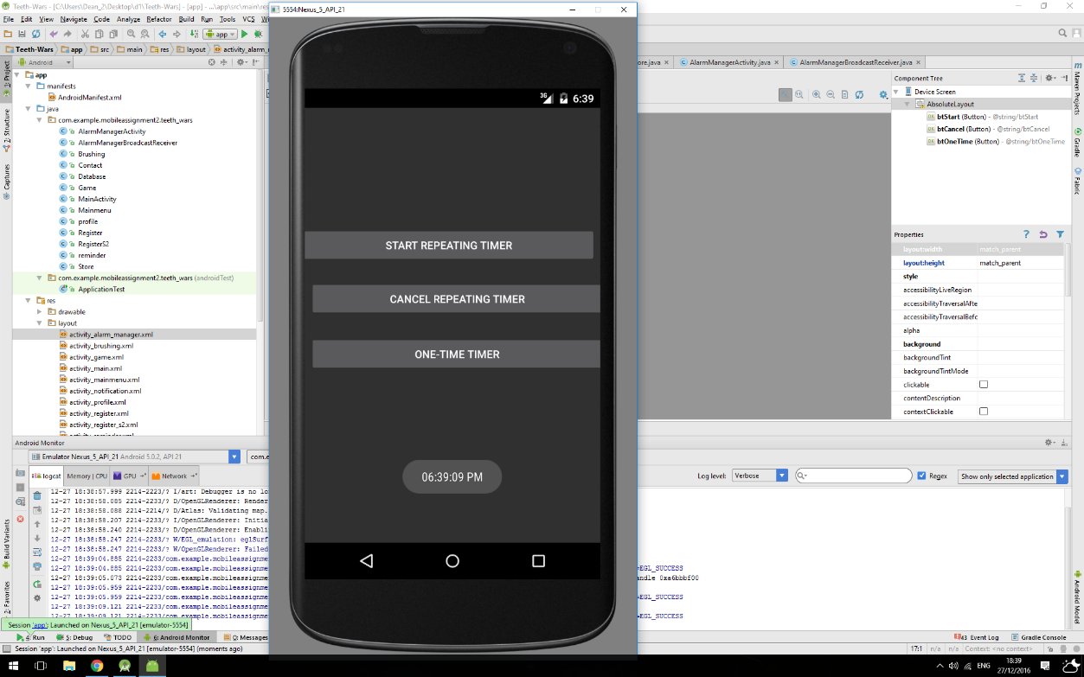**Push notification Comment** – One participant suggested that maybe some type of push notification could be useful to remind their child when to brush their teeth. After thinking about this it seemed like a good idea. The idea could be that the user inputs a specific time they wish to be notified each day to brush their teeth. This is arguably a complex feature, thus I decided to test this feature by developing a simple push notification application.

The development behind this feature was quite complex as it required many different handlers, to assist me with development I decided additional research was required. Research led me to an article that explained the process of developing this feature

Research Resource: <http://stackoverflow.com/questions/10715124/android-push-notifications-for-a-specific-time-using-alarm-manager> (Stackoverflow, 2012)

***Figure 23 – development push notifications***

**Development**

**Login/Register Screen**

These screens were rather simple to implement, in relevance to the interaction basis of these features also that was required was some text fields and input text fields for the user to input their own personal information. Once the user has inputted all of their personal information the user must interact with a button, this will then save all the details in a form of a String value to a Sql Lite database. Additionally, a second register page was also developed, the idea behind this page is for the user to select a default avatar, this again requires the user to interact with two buttons, dependent upon the button, it will change the avatar selected, similar to that of the functionality of a slideshow.

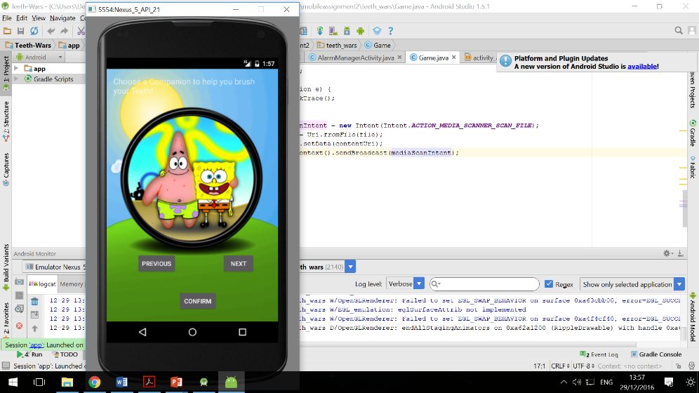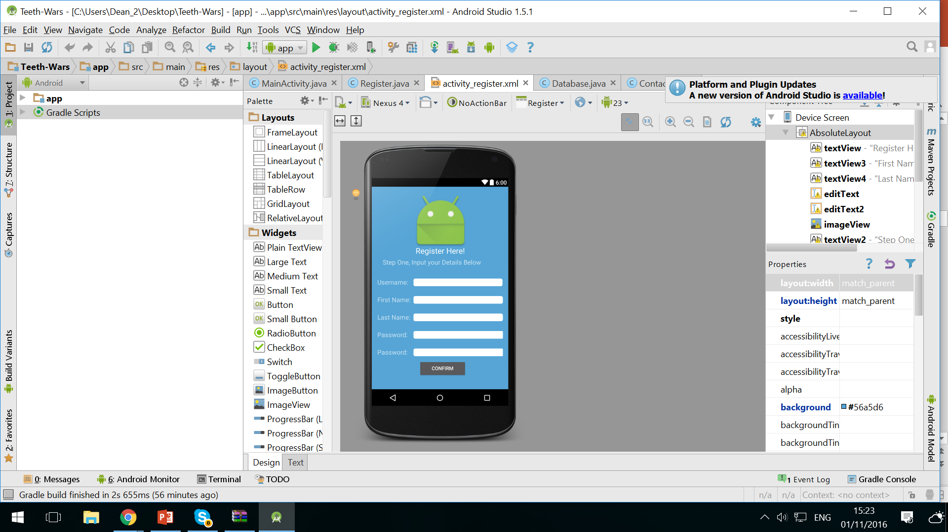

**To see Demonstration please visit:** [**https://youtu.be/GXDDW4EY0CY**](https://youtu.be/GXDDW4EY0CY)

***Figure 24 – development login/register***

**Store Screen**

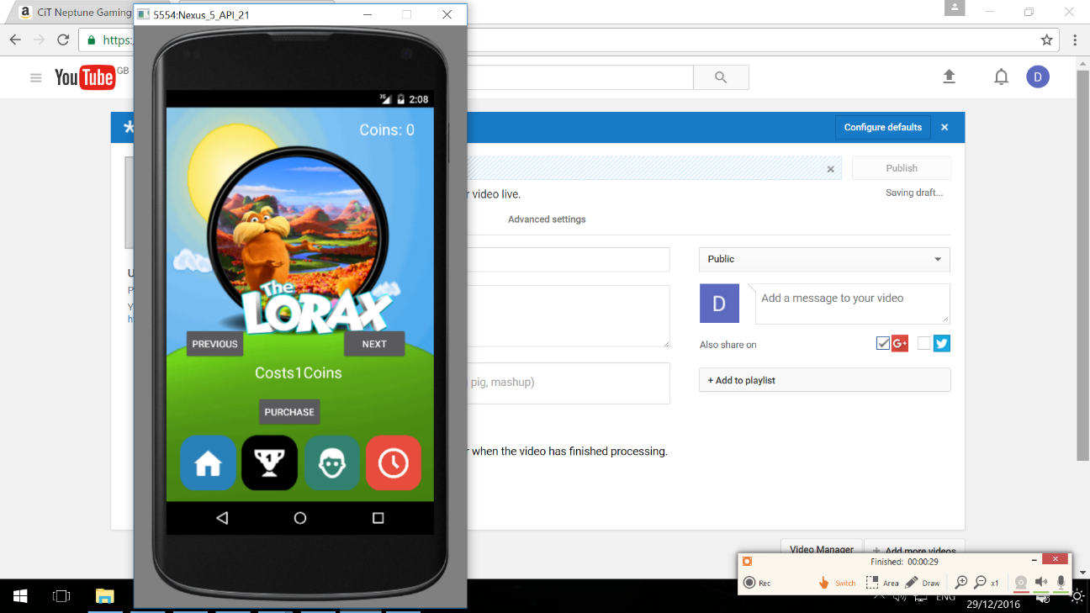This feature allows the user to buy a number of different avatars with coins they have been awarded for brushing their teeth. In relevance to the interaction required to use this feature the user must simply navigate between avatars using two buttons, one to navigate to the previous and the other to the next, lastly the user must interact with a confirmation button to purchase the selected avatar. In relevance to the development of this feature, the coins are firstly called from the Sql Lite database, this then allows for the application to know whether the user can afford the selected avatar dependent upon its cost. Lastly the slideshow feature works using an integer increment with an integer being assigned to each avatar, with the buttons either adding or taking from this integer. Lastly on confirming the user has enough coins to purchase the selected avatar, this then updates the coin value to the Sql Lite database and also selects the user avatar to the Sql Lite database.

***Figure 25 – development Store***

**To see Demonstration please visit:** [**https://youtu.be/nRpy3of71II**](https://youtu.be/nRpy3of71II)

**Brushing Feature**

This is the main feature of the application and incorporates many different elements of the application all together. In terms of the interaction between the user and the application, the user must simply click the button “start brushing” this will then activate the brushing feature, once this has occurred the child is then expected to begin brushing their teeth while the timer and other features begin, once the process of brushing their teeth has been completed, the child is rewarded with a coin and the ability to take a photo of their teeth.

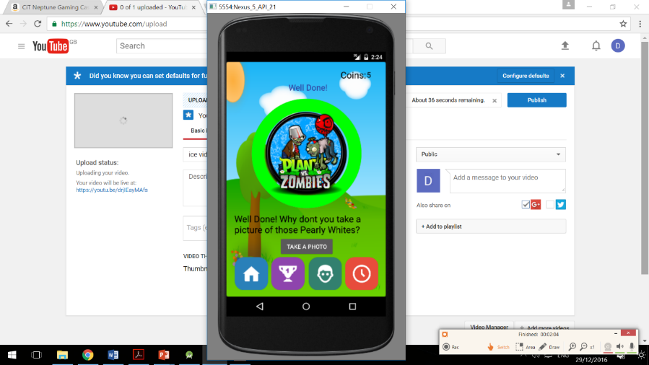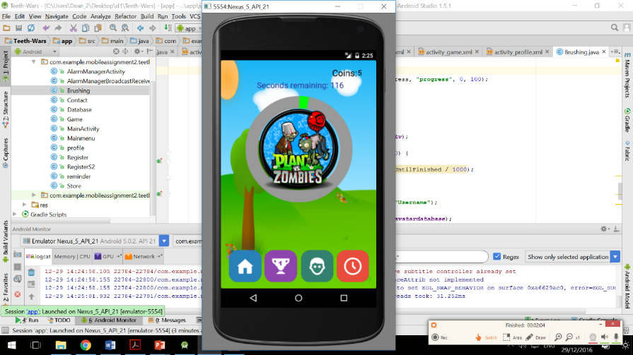In relevance to the development of this feature it firstly involved developing the circular timer, this can be seen in the Timer refinement section of this assignment, but as a brief statement, this involved creating a set duration and an animation to run under this set duration. Once this duration is completed an if statement can then read and output. Outputs include a new coin, which is again updated on the Sql Lite database, furthermore the photo button activation also becomes visible. Lastly the avatar is also called using an Sql Database, this selects the avatar that is present within the specific user’s database choice.

***Figure 26 – development brush feature***

**To see Demonstration please visit:** [**https://youtu.be/drjIEayMAfs**](https://youtu.be/drjIEayMAfs)

**Notification Reminder Feature**

This feature is arguably quite basic, but in real terms is actually quite problematic, due to many restrictions within user’s phones. The interaction required to use this feature requires the user to input a specific time they wish the notification to appear, once this has been inputted the user must simply confirm this by pressing a confirmation button. Alternatively, the user can also cancel this notification process by interacting with another button.

In terms of the development process, it was quite simple to implement due to previously testing the possibility of using this idea, which meant that minor tweaks such as the ability to implement when a notification occurs were the main elements of the development process. As an explanation of how this feature was developed, it uses the inbuilt calendar feature within the phone to determine both the time and date, then if this corresponds to the users request it will display a notification.

**To see Demonstration please visit:** [**https://youtu.be/FD_l_L2v73Q**](https://youtu.be/FD_l_L2v73Q)

**Testing Iteration Two**

This iteration of testing is exactly the same as the previous and will use the same participants to provide for the fairest results. In relevance to the first phase of testing, which involved the testing of the usability, the only changes made were a few different tests, this was due to a number of new features within the application. The following results were achieved.

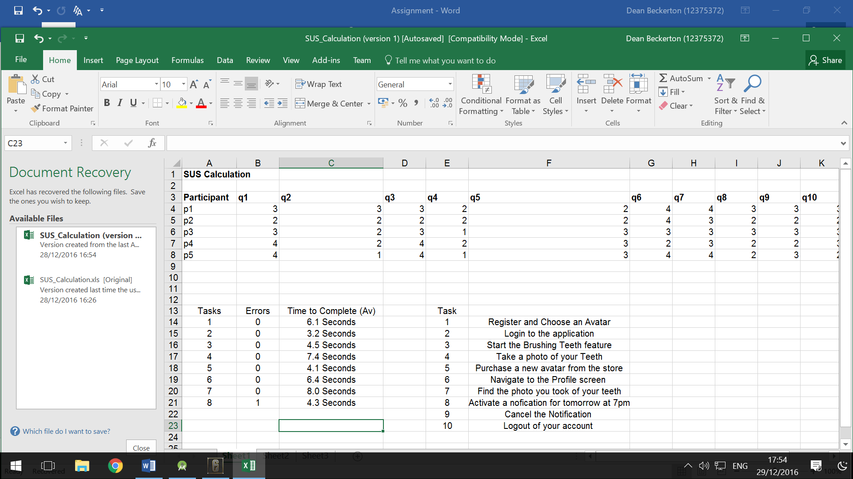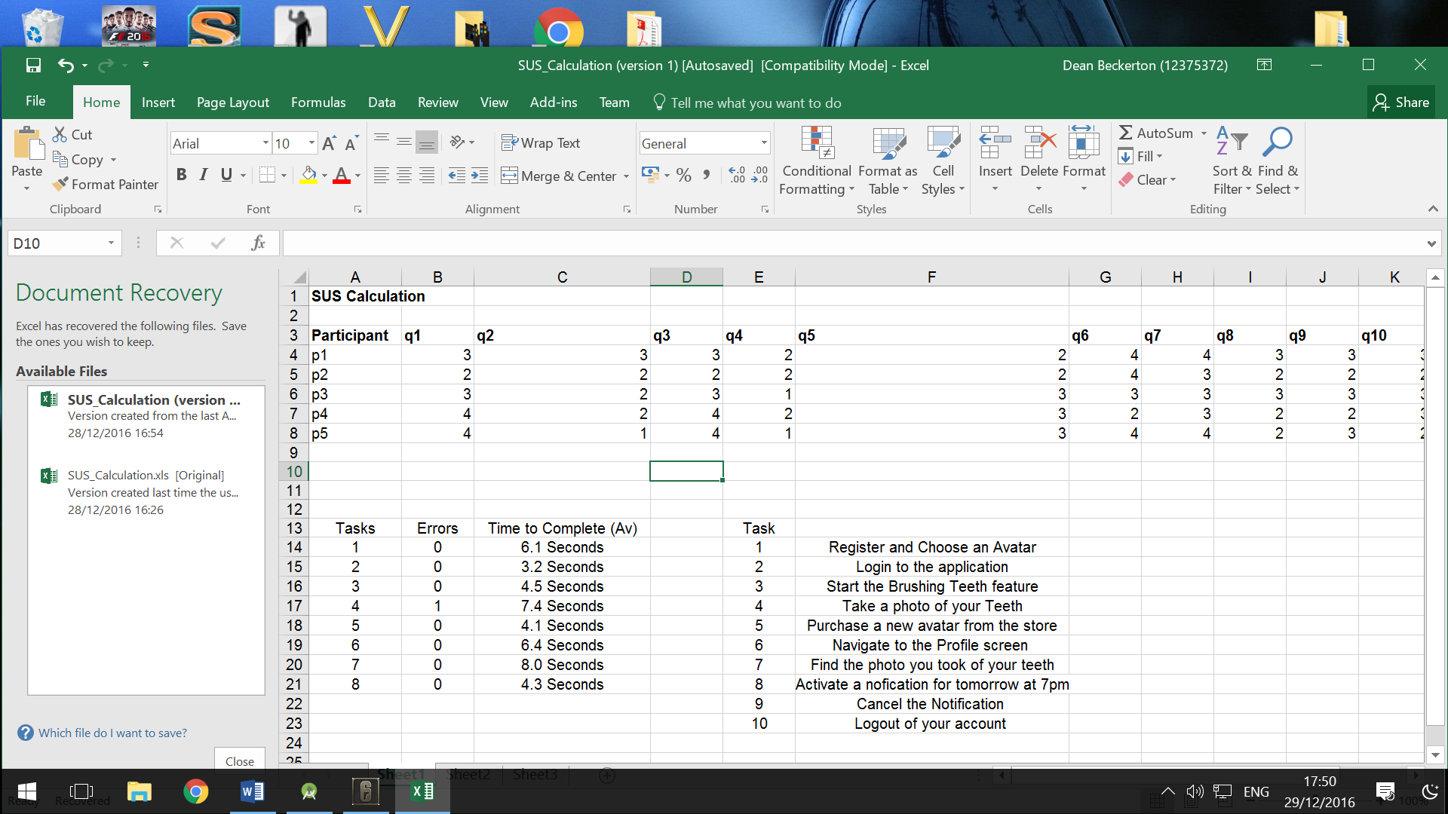

***Figure 27 – iteration two testing usability***

The results clearly show a significant improvement, since that of the previous testing iteration. This can be seen through both the lower number of errors present but also the lower time to complete each given task. Although one error was present, this was due to a user being confused on how to use the notification feature, this could be something to reflect upon and possibly change.

The next testing method was the system usability scale. This was completed to the exact format and specification as the previous. Results are shown below.

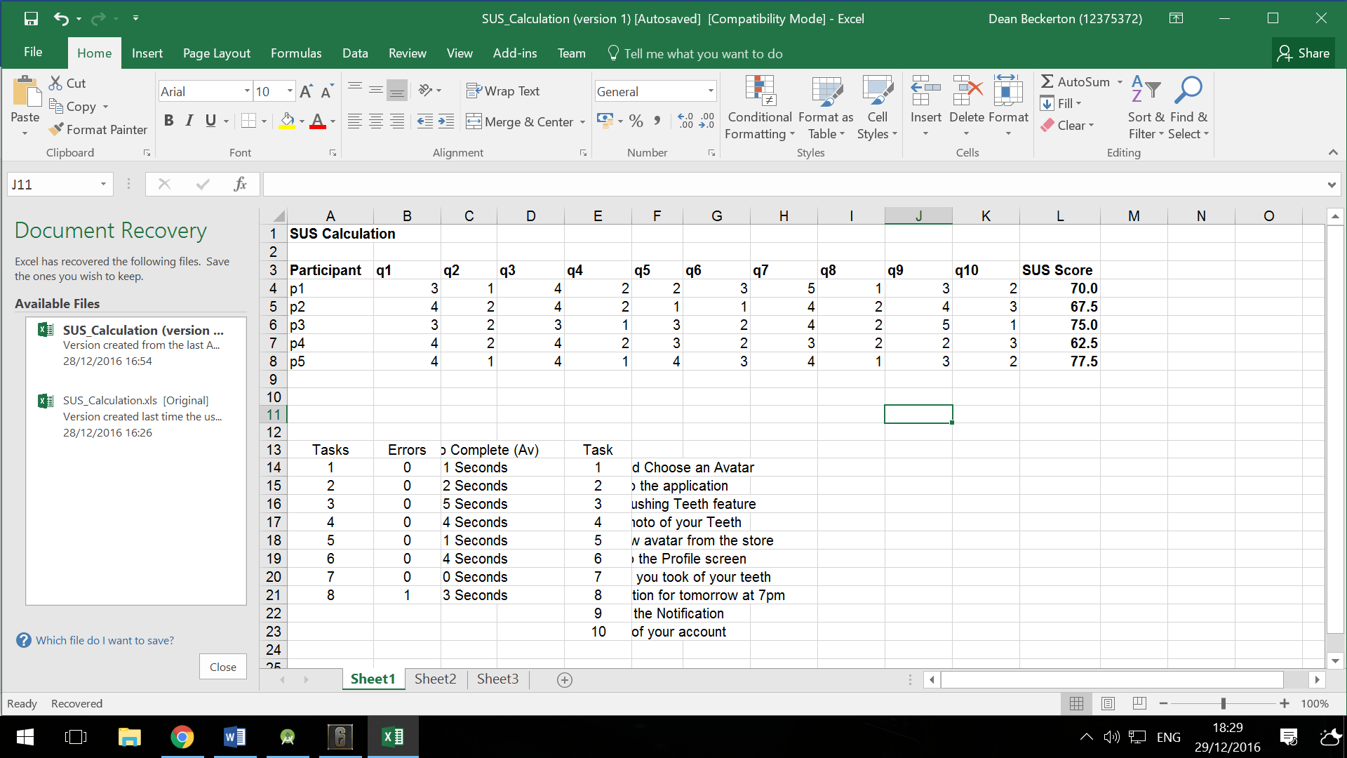

***Figure 28 – SUS iteration two***

Again it is clear to see there is a large improvement in the results, with most participants scoring the application over 70, which is the ideal score and also the highest score now being 77.5. Although there is still one participant who scored the system usability as 62.5, this is still a massive improvement but also shows there is clear room for additional refinement.

**Comments (iteration Two)**

**Positive Comments**

**Avatar idea and customisation options and Circular timer is awesome**

**Store to Purchase Avatars with in game currency**

 **Bottom navigation menu easy to use and understand**

**Reward system good idea**

**Camera Feature and ability to look at old teeth photos**

**Negative Comments**

**Teeth feature could do with sound**

**Login screen is empty and no application logo?**

**register inputting detail not clear**

**Main menu has lots of empty space**

**Fonts colour contrast with background**

**Refinements (Iteration Two)**

**Teeth feature could do with sound –** This was a rather easy refinement in terms of development. This simply involved downloading a specific song or sound and place it within the application, once within the application it can be activated with the interaction of a button, in this case it is the “brushing button”

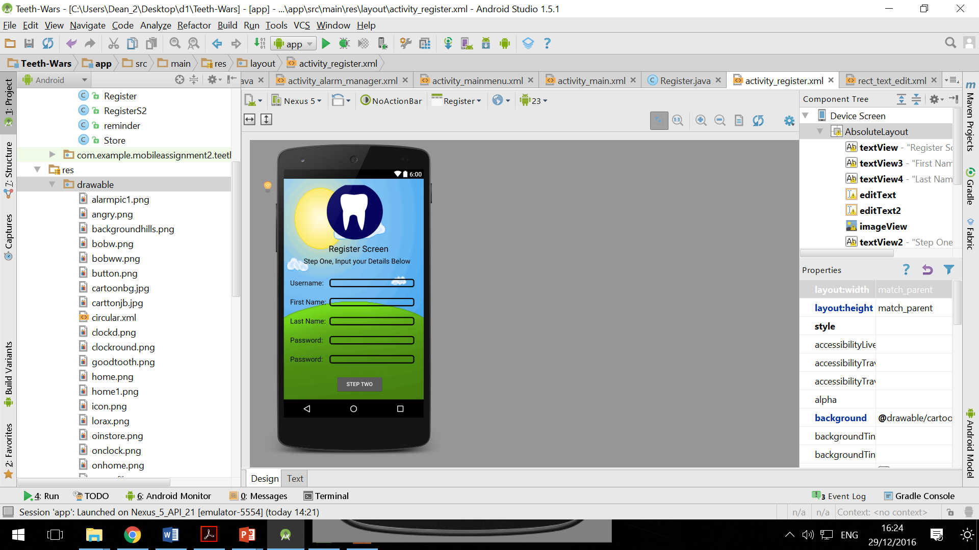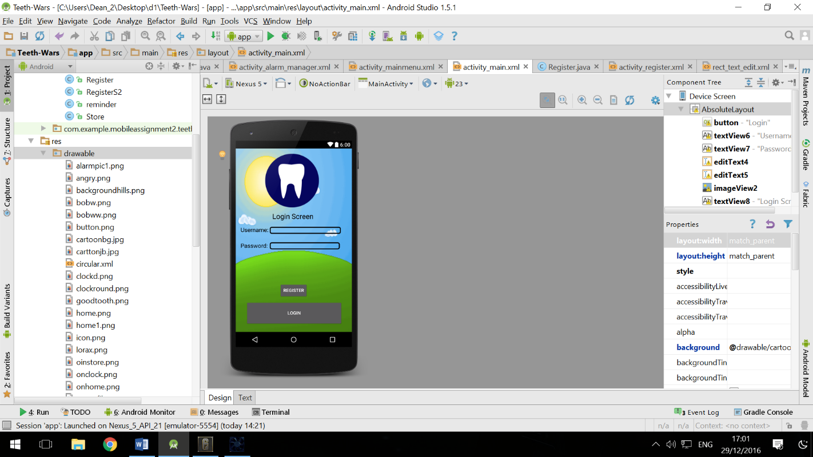In relation to the rest of the negative comments, they were again relatively easy refinements. In terms of the login and register screen a clearer input box is now being used, furthermore all font within the application is now black to prevent any contrast with foreground or background elements. Lastly a logo has now been chosen for the application, this will also be currently used to fill the empty space within the main menu screen. See examples below.

***Figure 29 – Refinement iteration two***

**Refinement conclusion** – After looking at the test results there are no longer any significant refinements required that argue the usability of this application is not of a high quality. Therefore, I believe it is now at the point where it could be releasable to the public but still have weekly or monthly refinements.

**Future Improvements**

In terms of future improvements to this artefact it could be appropriate to refine a number of the existing features. Firstly, maybe a more professional and child friendly font may be applicable to implement, as arguably the text font currently is quite boring. Another refinement I would make would be to develop a more professional looking background as this as a whole would make the application look a much higher quality to the user. Lastly I would also look to implement many more avatars to make the customisation and reward range much more diverse.

**Appendix**

**Item One – Paper Prototype Idea Two**

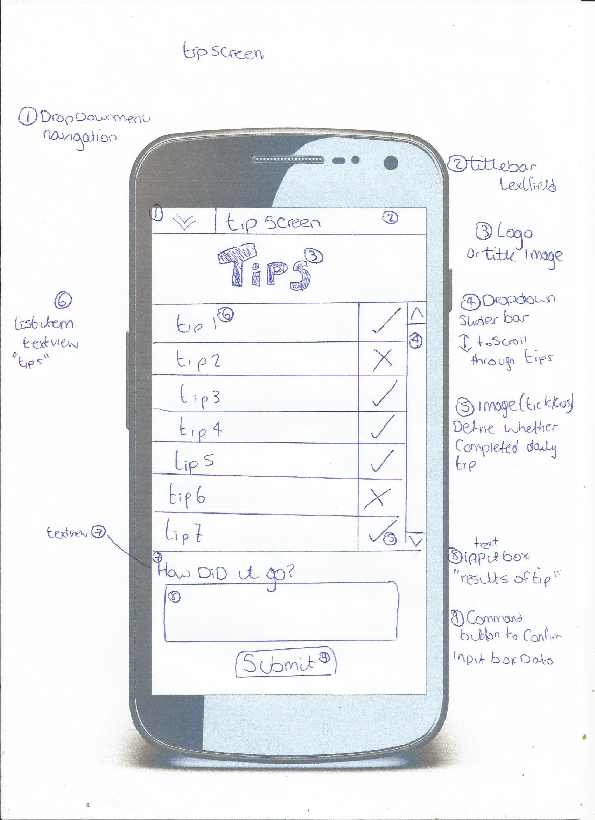

**For all Pages please check the support documents file**

**Item Two – Paper Prototype Idea Three**

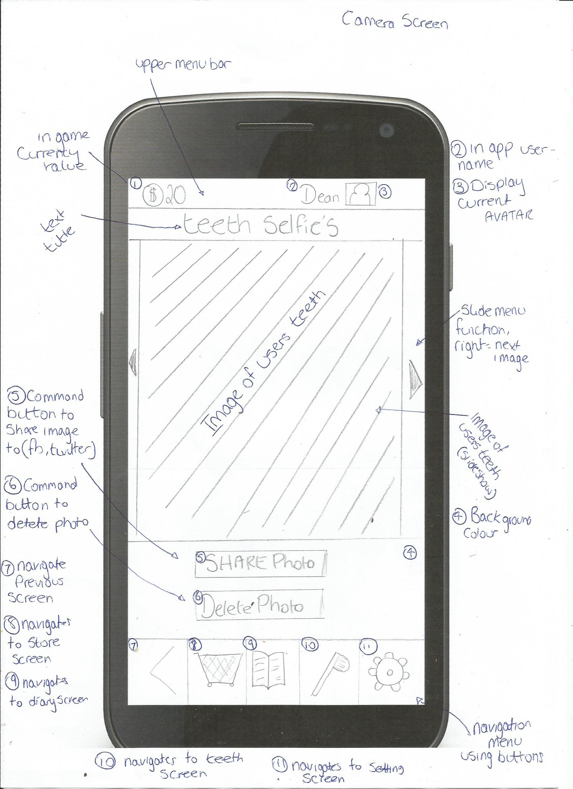

**For all pages visit support documents**

**Item Three – System usability scale**

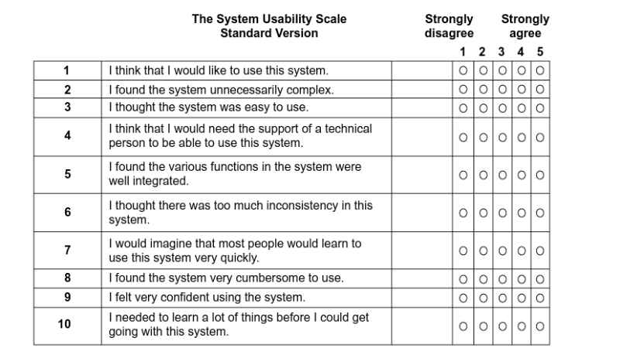

References

1. Dictionary. (2016) Definition of intolerance. [Online] Available from: <http://www.dictionary.com/browse/intolerance> [Accessed 01/11/2016]
2. Ofcom. (2015) The UK is now a smartphone society. [Online] Available from: <https://www.ofcom.org.uk/about-ofcom/latest/media/media-releases/2015/cmr-uk-2015> [Accessed 06/11/2016]
3. Cnet. (2016) Windows Phone market share falls below 1 percent. [Online] Available from: <https://www.cnet.com/uk/news/windows-phone-market-share-falls-below-one-percent/> [Accessed 06/11/2016]
4. Clinical Depression. (2016) Major Depression Facts. [Online] Available from: <http://www.clinical-depression.co.uk/dlp/depression-information/major-depression-facts/> [Accessed 01/11/2016]
5. Mental Health. (2015) Fundamental Facts About Mental Health. [Online] Available from: <https://www.mentalhealth.org.uk/sites/default/files/fundamental-facts-15.pdf> [Accessed 01/11/2016]
6. The Family Dinner Project. (2016) Conversation Starters. [Online] Available from: <http://thefamilydinnerproject.org/conversation-2/conversation-starters/> [Accessed 27/11/2016]
7. StackoverFlow. (2011) random-numbers-with-math-random-in-java. [Online] Available from: <http://stackoverflow.com/questions/7922978/random-numbers-with-math-random-in-java> [Accessed 27/11/2016]
8. Anxiety BC. (2016) self-help strategies for social anxiety. [Online] Available from: <https://www.anxietybc.com/sites/default/files/adult_hmsocial.pdf> [Accessed 27/11/2016]
9. TopTens. (2015) 10 Best Kids Shows. [Online] Available from: <http://www.thetoptens.com/best-kids-shows/> [Accessed 06/11/2016]
10. FDM. (2013) Why the role of a Software Test Analyst is so vital. [Online] Available from: <http://www.fdmgroup.com/a-career-in-testing-why-the-role-of-a-software-test-analyst-is-so-vital/> [Accessed 07/11/2016]
11. NN Group. (2014) Turn User Goals into Task Scenarios for Usability Testing. [Online] Available from: <https://www.nngroup.com/articles/task-scenarios-usability-testing/> [Accessed 07/11/2016]
12. TheNextWeb. (2014) 20 creative ways to test your design. [Online] Available from: <http://thenextweb.com/dd/2014/12/23/20-creative-ways-test-design/> [Accessed 07/11/2016]
13. Usability Gov. (2015) Running a Usability Test. [Online] Available from: <http://www.usability.gov/how-to-and-tools/methods/running-usability-tests.html> [Accessed 29/12/2016]
14. Material io. (2016) Bottom navigation. [Online] Available from: [https://material.io/guidelines/components/bottom-navigation.html#](https://material.io/guidelines/components/bottom-navigation.html) [Accessed 29/12/2016]
15. Icons8. (2016) All the Icons You Need. Guaranteed. [Online] Available from: <https://icons8.com/> [Accessed 29/12/2016]
16. Stackoverflow. (2014) How to Create a circular progressbar in Android which rotates on it? [Online] Available from: <http://stackoverflow.com/questions/21333866/how-to-create-a-circular-progressbar-in-android-which-rotates-on-it> [Accessed 29/12/2016]
17. Stackoverflow. (2012) Android Push notifications for a specific time using Alarm Manager[Online] Available from: <http://stackoverflow.com/questions/10715124/android-push-notifications-for-a-specific-time-using-alarm-manager> [Accessed 29/12/2016]
18. NHS. (2015) Stress, anxiety and depression. [Online] Available from: <http://www.nhs.uk/Conditions/stress-anxiety-depression/Pages/low-mood-stress-anxiety.aspx> [Accessed 29/12/2016]
19. Quick Brush (2015) The Quick Brush App. [app] version 1.0. Available from: <https://play.google.com/store/apps/details?id=com.samynakayamadriss.samydriss.quickbrush> [Accessed 29/12/2016]
20. Australian Unity. (2015) Brush Teeth with The Wiggles. [app] version 1.0. Available from: <https://play.google.com/store/apps/details?id=au.com.australianunity.wigglesbrush> [Accessed 29/12/2016]
21. Disney. (2015) Disney Magic timer. [app] version 3.7. Available from: <https://play.google.com/store/apps/details?id=com.disneydigitalbooks.DisneyMagicBrushTimer_goo> [Accessed 29/12/2016]